

***System Admin***

***Training Assignments***

|  |  |
| --- | --- |
| Program Code |  |
| Issue/Revision | x/y |
| Effective date | 04/Aug /2023 |

**Assignment day 23: Setting Up Full HA WebApp WordPress – Oncloud AWS Infrastructure**

**Mục Lục**

Kiến trúc hạ tầng 3

Tóm tắt các bước chính cần thực hiện 3

Tạo Database RDS for MySQL 3

Tạo máy ảo EC2 10

Chọn AMI 10

Choosing an instance type 12

Configuring an SSH key 13

Configuring a security group and lauching your instance 14

Launch 16

Thông Kết nối Network EC2 với RDS 16

SSH into your EC2 instance 16

Tạo DB User cho ứng dụng và thử kết nối từ VM 16

Tạo Storage EFS ( Elastic File System) 16

Create EFS 16

Attach EFS to EC2 16

Cài đặt WordPress 16

Cài đặt Apache webserver 16

Download and configure Wordpress 16

Deploying Wordpress 16

Tạo Application Loadbalance ( ALB) 16

Tạo AMI từ EC2 16

Tạo ASG lauching từ AMI vừa tạo 16

Clean up 16

Remove EC2 16

Delete Database RDS 16

Remove EFS 16

## Kiến trúc hạ tầng

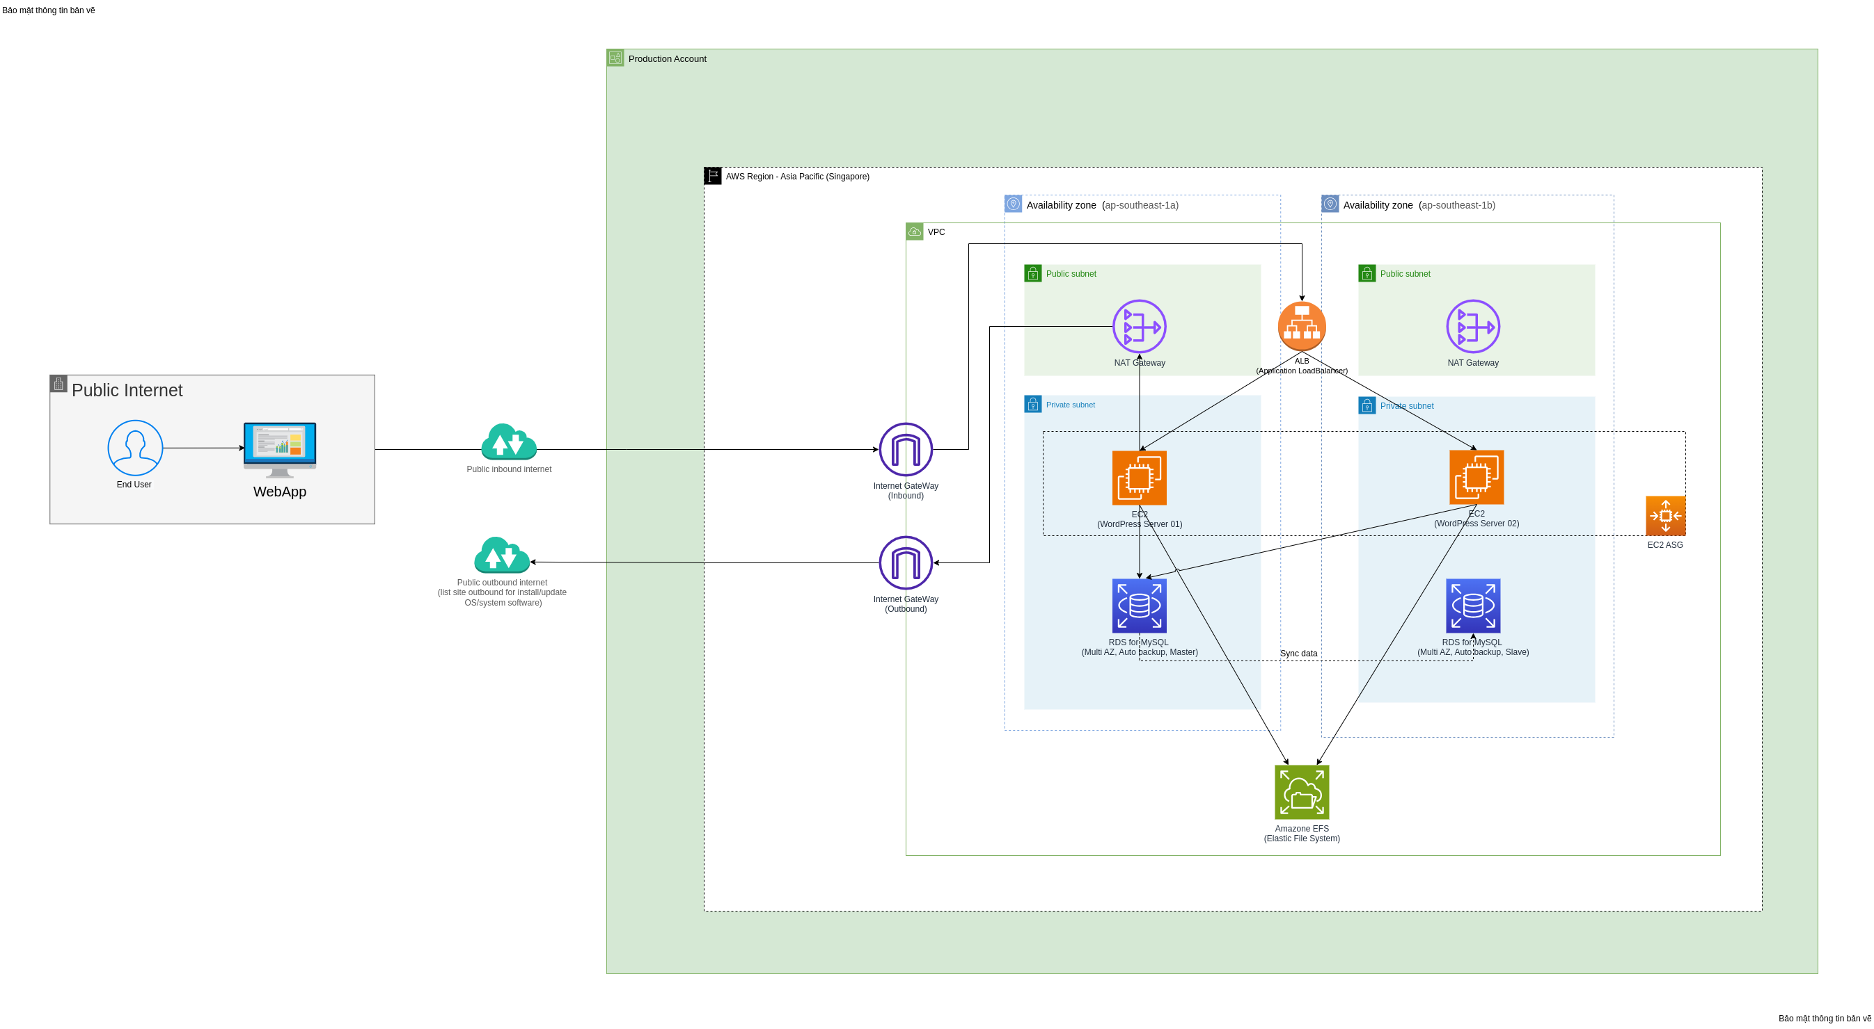

## Tóm tắt các bước chính cần thực hiện

* Tạo tài khoản AWS
* Tạo cân bằng tải ALB. security group cho phép truy cập từ 0.0.0.0/0 di qua cổng 80 và 443
* Tạo EFS storage, cho phép security group inbound từ ASG.
* Tạo Database RDS for mysql. Cho phép security group inbound từ cụm ASG. Lưu lại endpoint, user, pass, DB name để tiến hành khai báo trong config file của wordpress.
* Tạo 1 máy ảo VM base. Cài đặt các phần mềm hệ thống + triển khai code wordpress trong đó. Sau khi cài đặt và kiểm thử work. Tiến hành tạo ảnh AMI. Các máy ảo tiếp theo trong ASG sẽ sử dụng AMI này để khởi tạo dịch vụ. Security Group chỉ cho phép truy cập từ ALB
* Lưu ý: Để máy ảo có thể truy cập được internet cài đặt gói. Tiến hành tạo NAT gateway trong public subnet, tiến hành routing kết nối từ ASG tới NAT gateway và từ NAT Gateway tới Internet Gateway.

## Tạo Database RDS for MySQL

a. Open the [AWS Management Console](https://console.aws.amazon.com/console/home). When the screen loads, enter *RDS* in the search bar, then select RDS to open the service console.

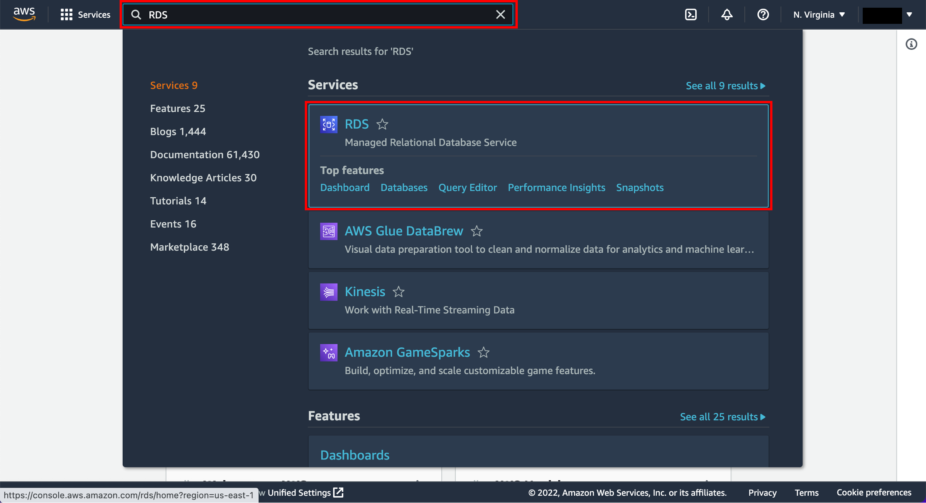

b. Choose the Create database button to get started.

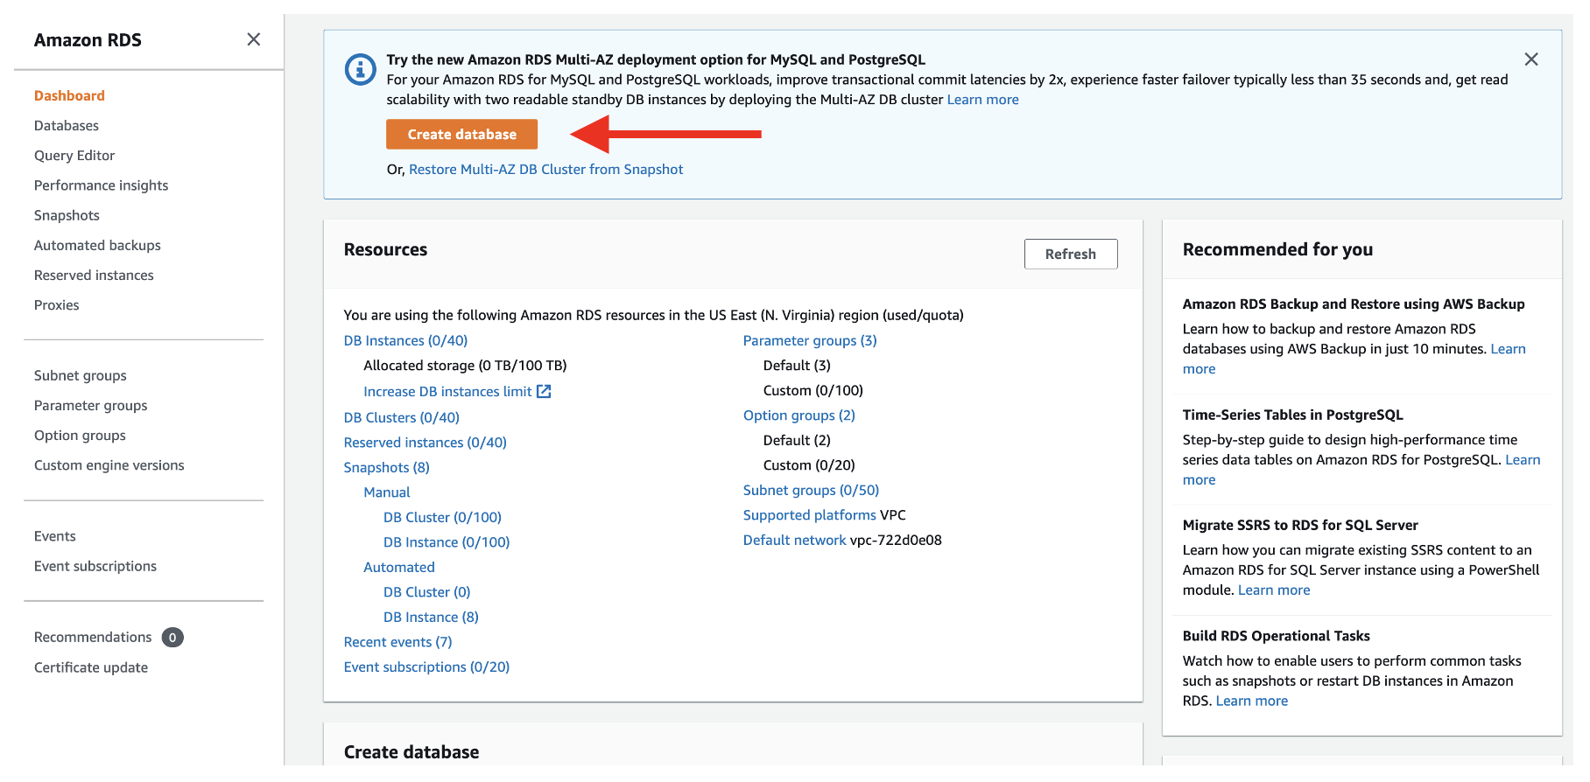

c. The first step is to choose the database engine you want to use. Amazon RDS supports six different engines, from popular open-source options like MySQL and PostgreSQL, to commercial options like Oracle and Microsoft SQL Server, to a cloud-native option called Amazon Aurora that was custom-built to take advantage of the cloud.

WordPress uses MySQL, so select Standard create for the database creation method and choose the MySQL engine.

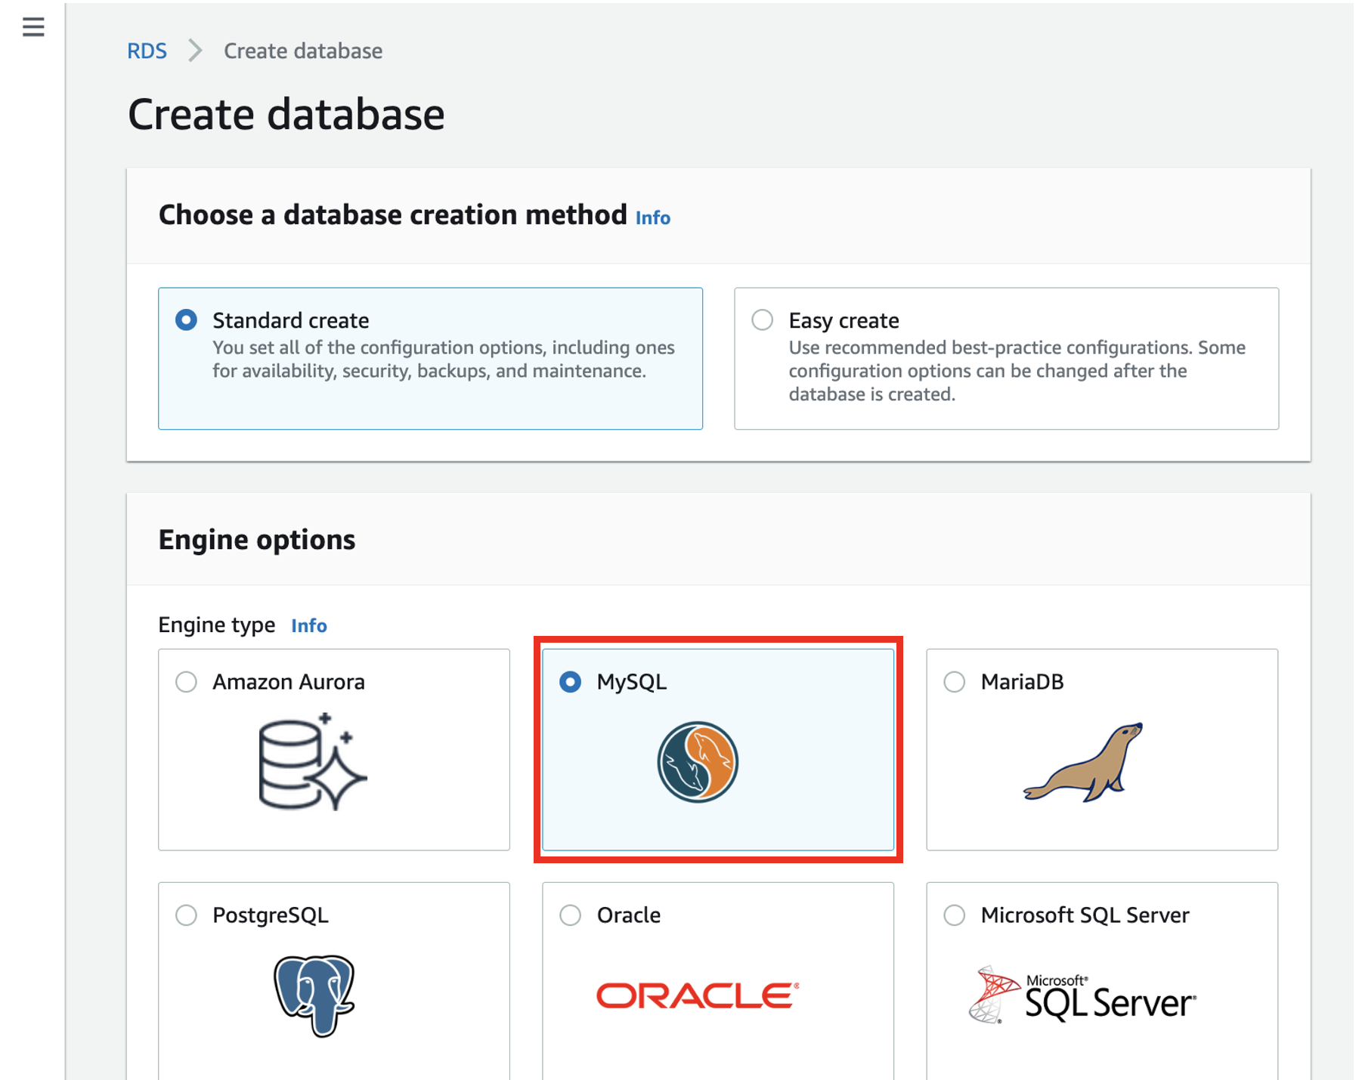

d. In the Templates section of the creation wizard, there is an option to only show options that are available in the [AWS Free Tier](https://aws.amazon.com/free/). Select this option to complete the learning in this guide without incurring costs.

In a production setup, you may want to use features of Amazon RDS that are outside the Free Tier. These include:

* A larger database instance class, for improved performance
* [Multi-AZ deployments](https://aws.amazon.com/rds/details/multi-az/), for automatic failover and recovery in the event of an infrastructure issue
* [Provisioned IOPS for disk storage](https://docs.aws.amazon.com/AmazonRDS/latest/UserGuide/CHAP_Storage.html#USER_PIOPS), for faster I/O performance

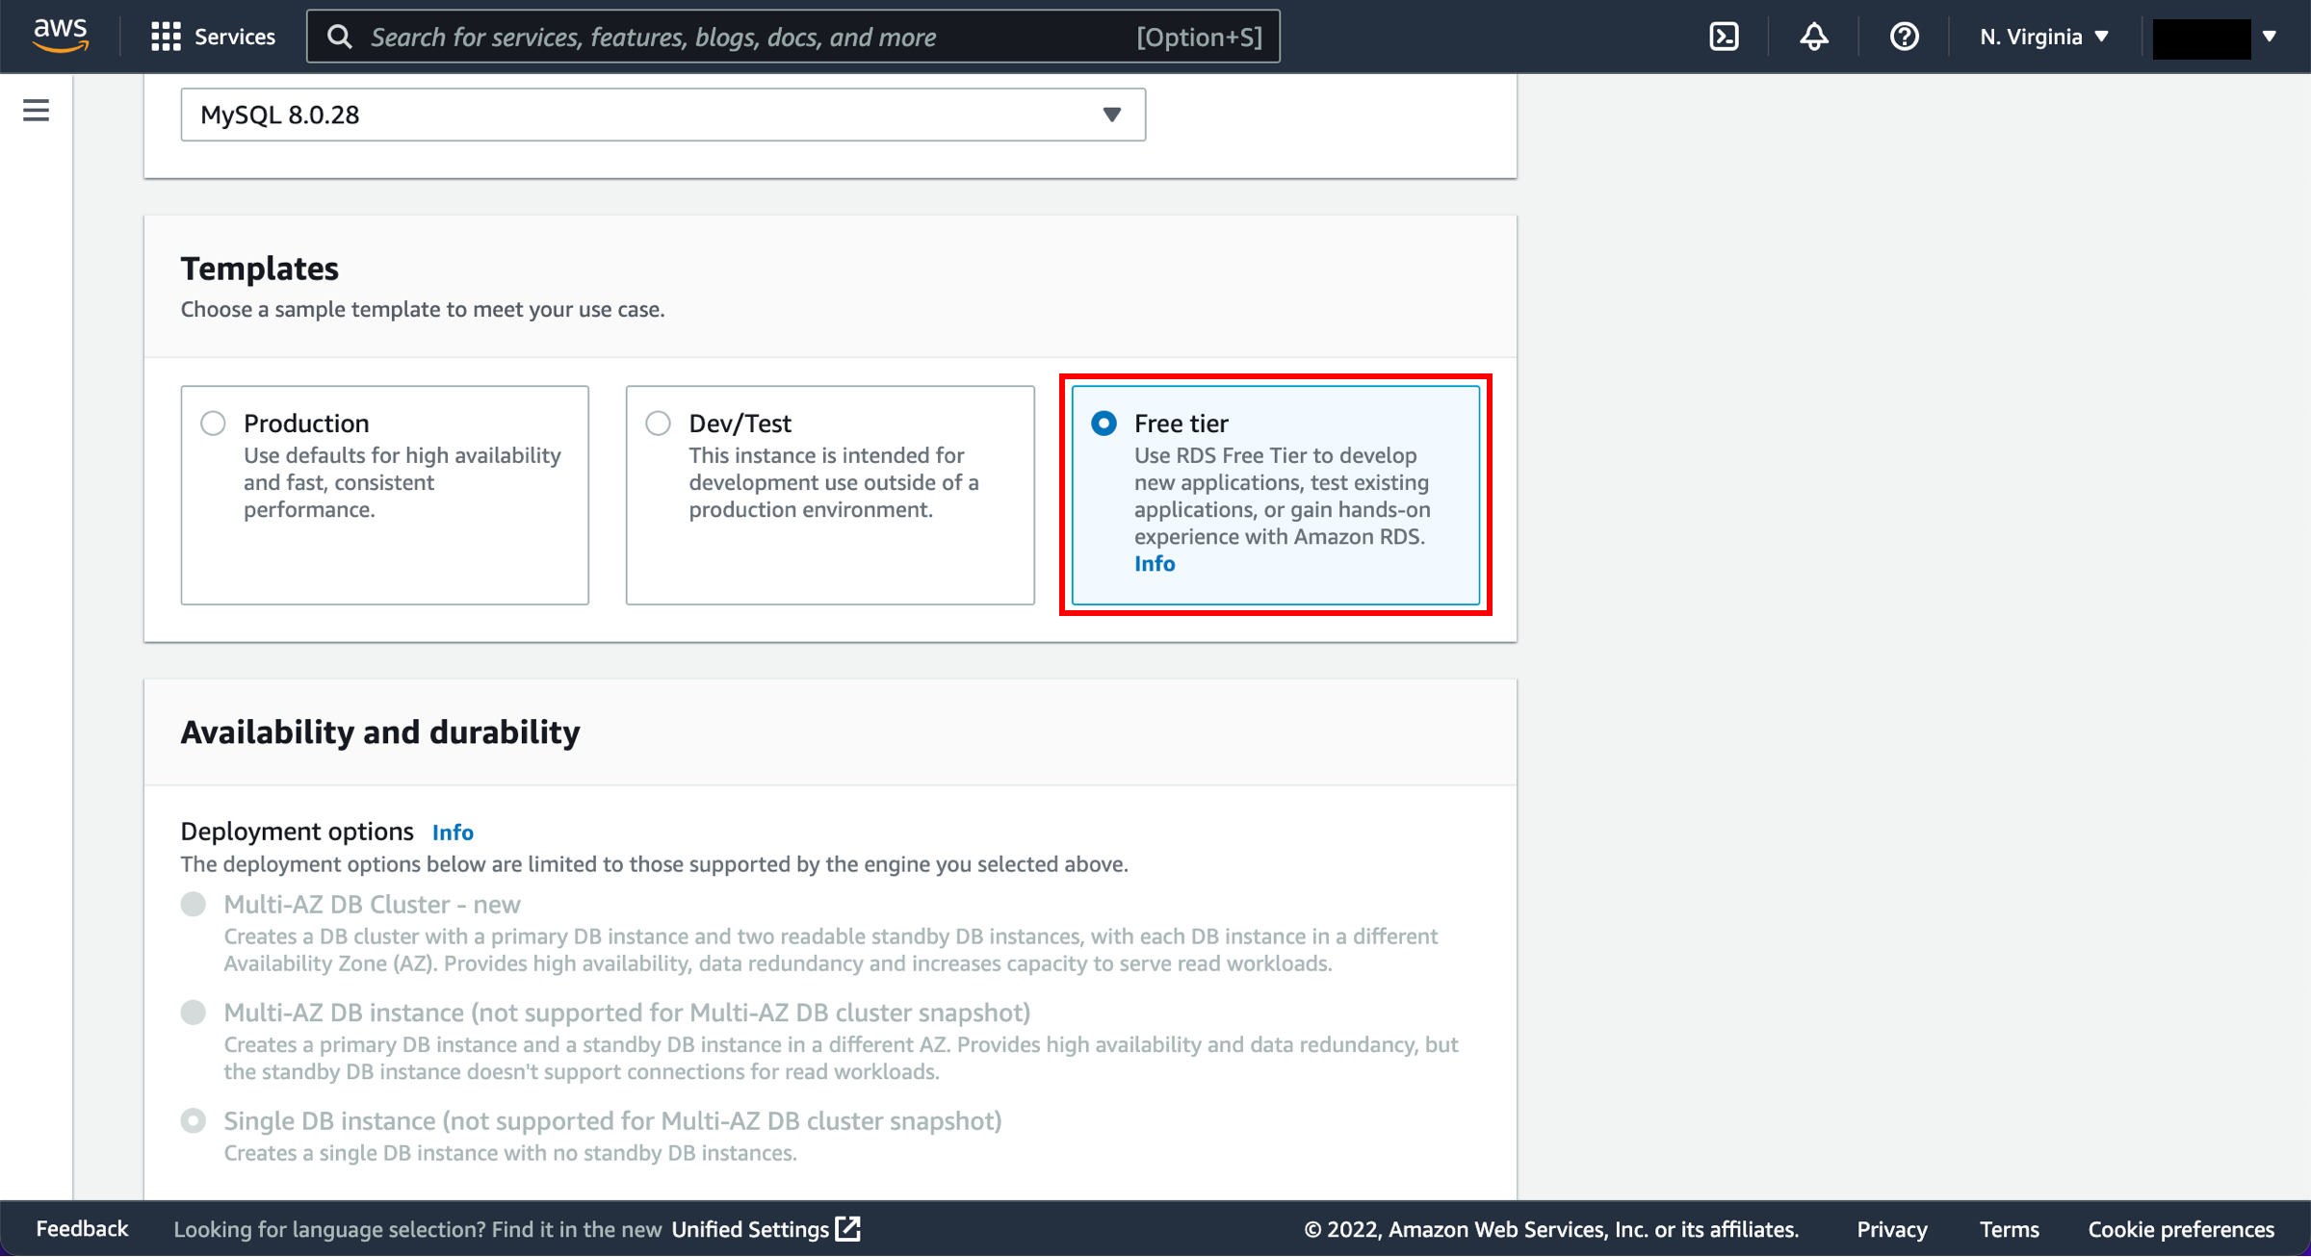

e. Next, you will specify the authentication settings for your MySQL deployment. These include the database name and the master username and password.

In the Settings section, enter wordpress as your DB instance identifier. Then specify the master username and password for your database. Choose a strong, secure password to help protect your database. Store the username and password for safekeeping as you will need it in a later module.

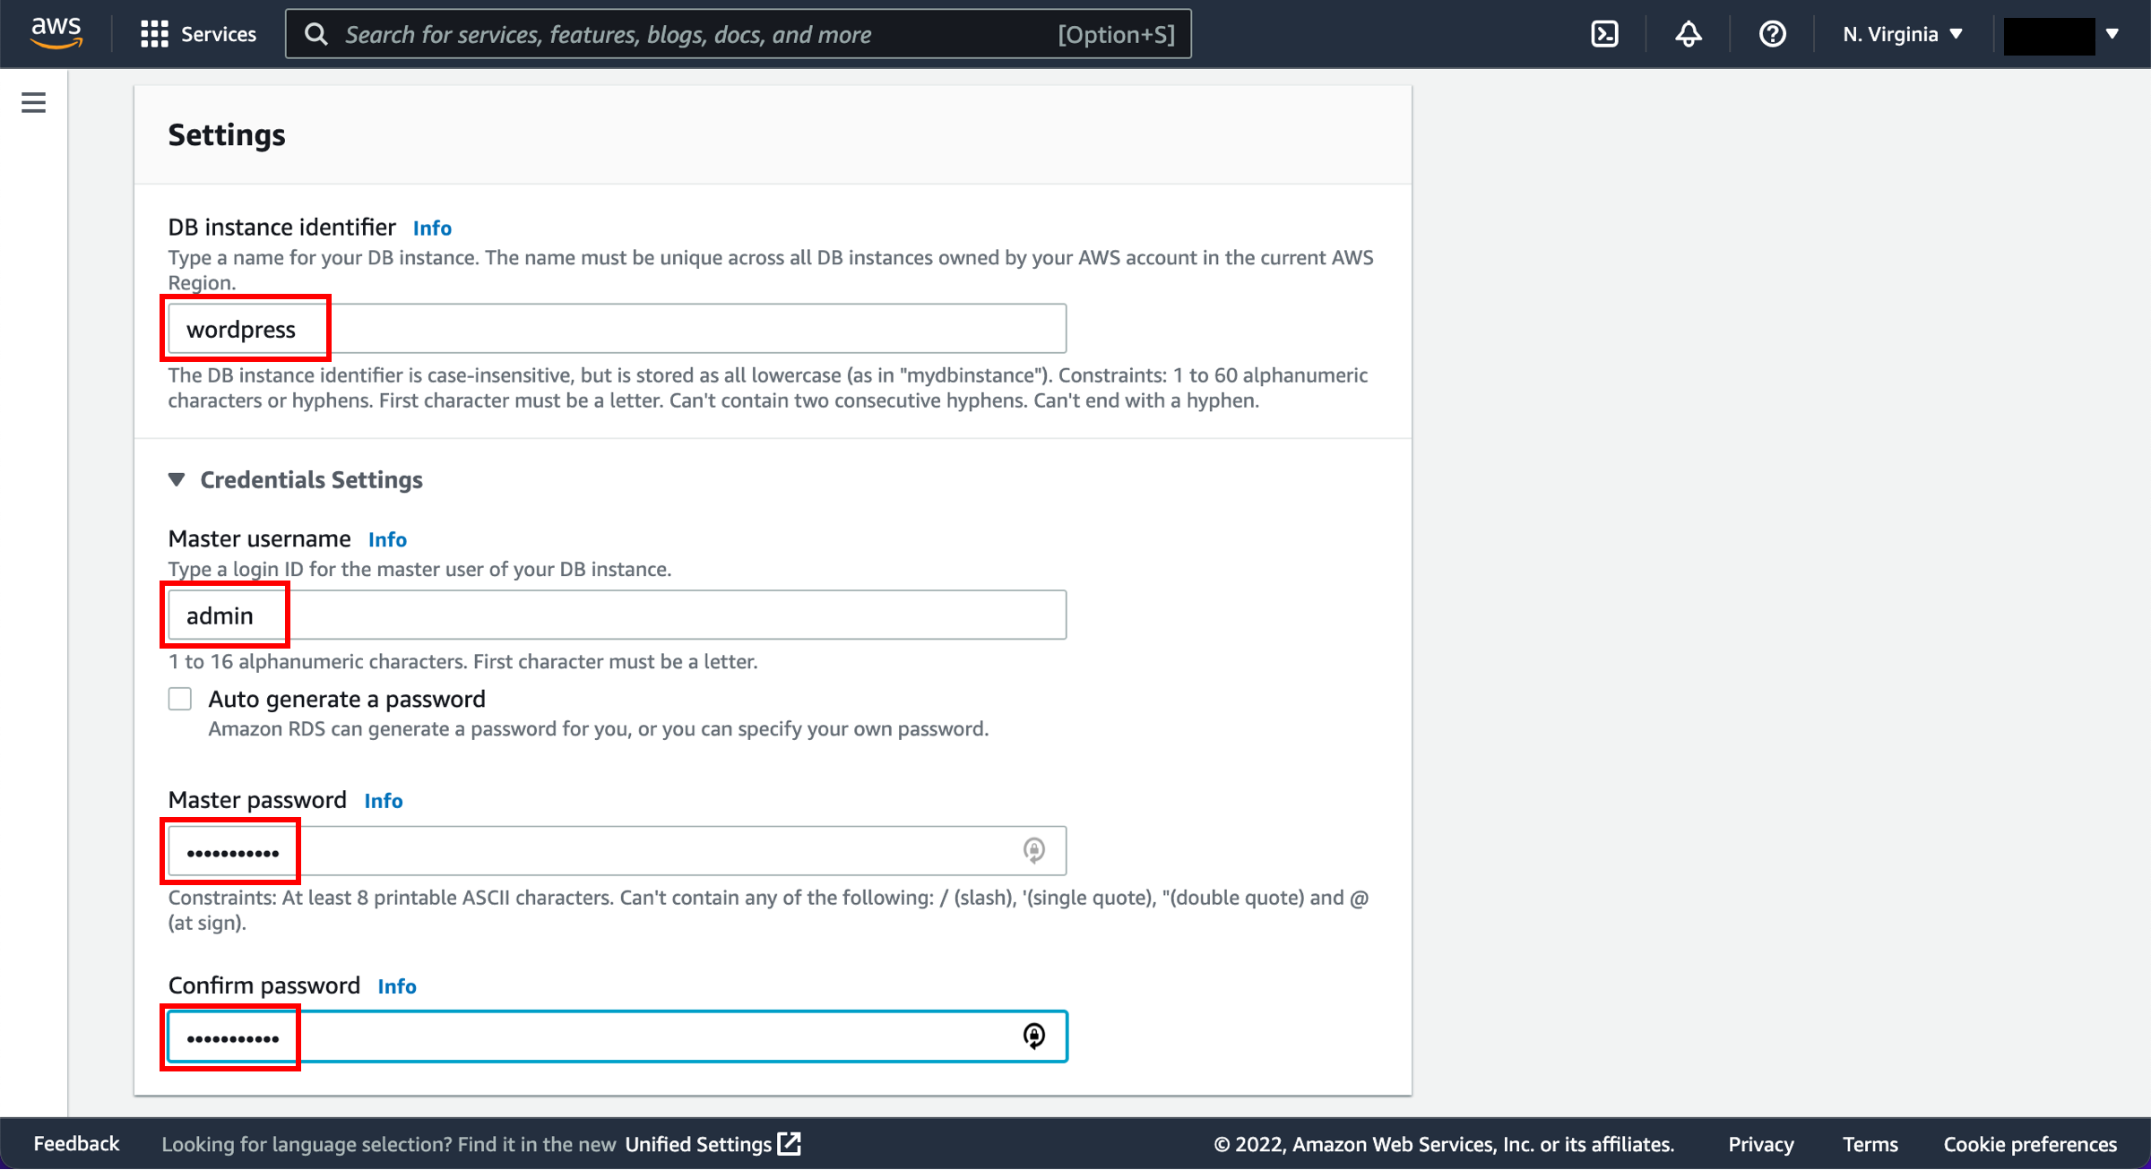

f. After setting your username and password, you can select key details about your MySQL deployment. This includes the instance configuration and storage details.

The default settings will work for this guide. You will use a small instance class that is suitable for testing or small-scale applications, and it fits within the AWS Free Tier. If you don’t want to use the AWS Free Tier, you could set a larger instance class or alter the storage configuration options.

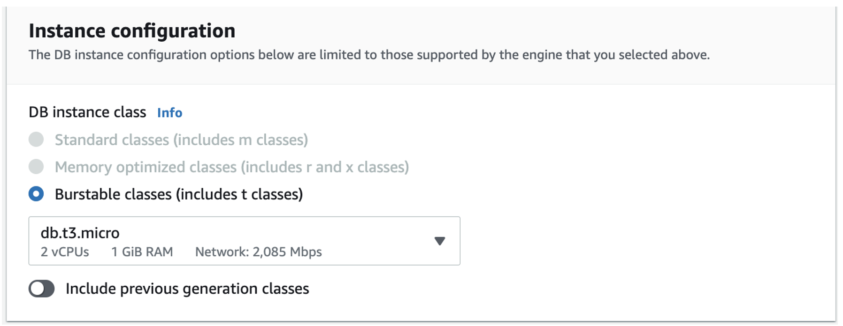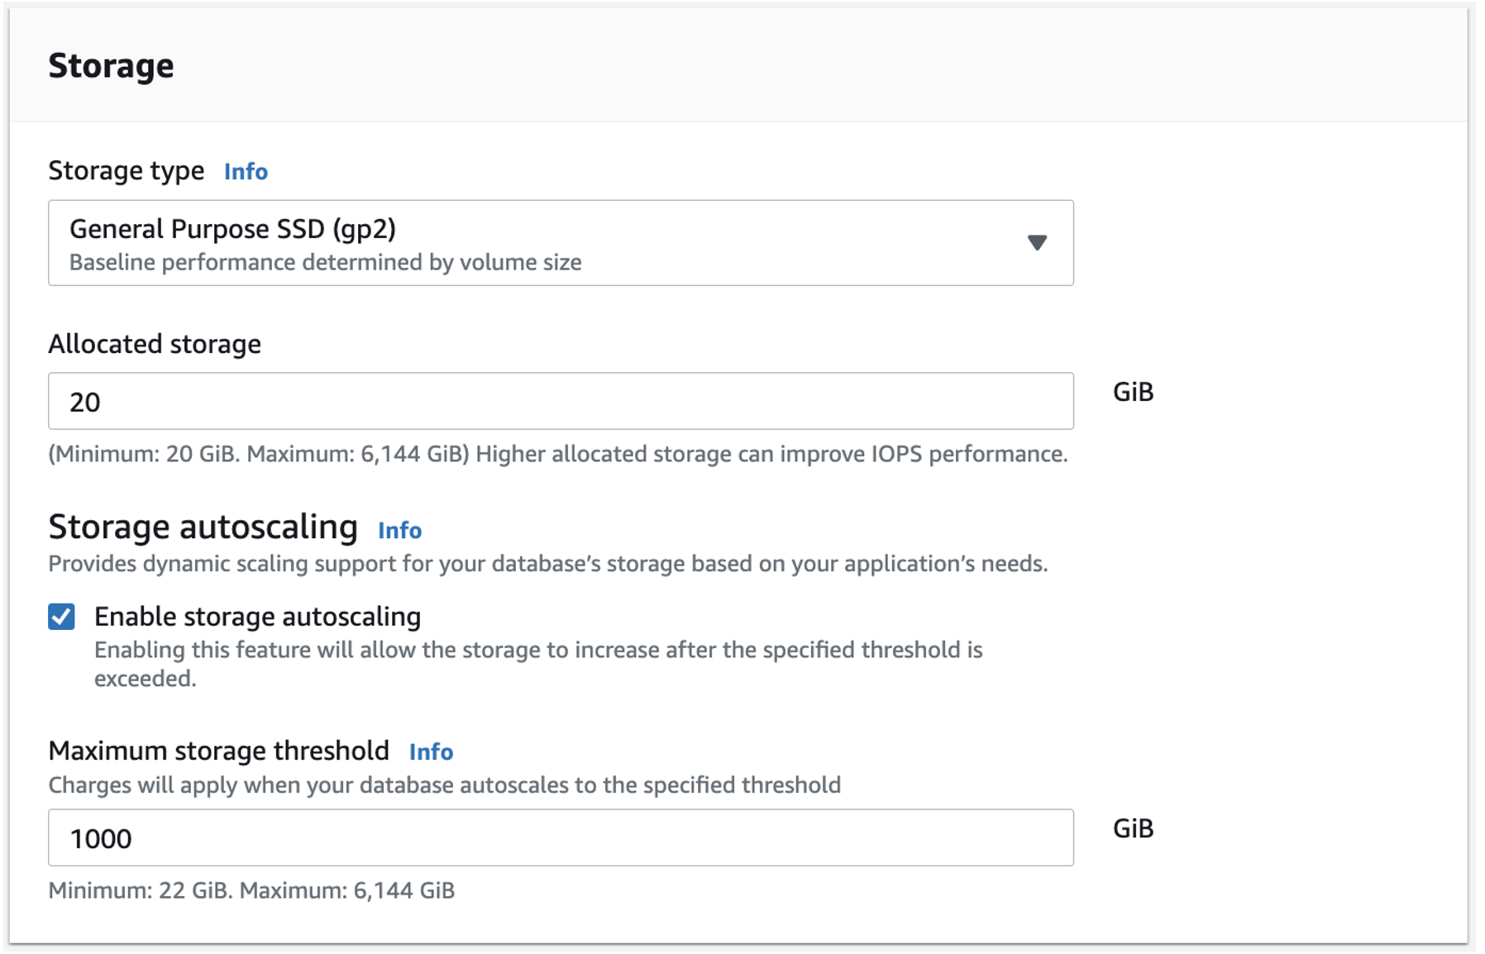

g. Next, you can configure connectivity and network settings. Amazon RDS instances must be created in an Amazon VPC, which is a logically separate network where your provisioned resources will live.

VPCs are an advanced topic outside the scope of this guide. Fortunately, AWS has created a default VPC in each Region in your account. The default VPC is already selected for you, and you can launch your Amazon RDS instance in this VPC.

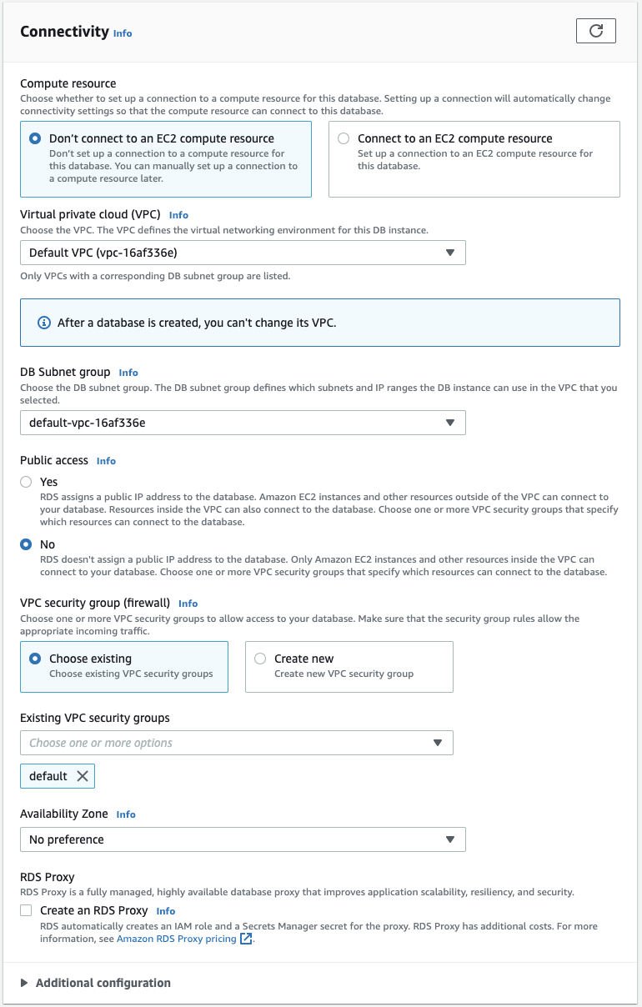

h. Finally, Amazon RDS provides a number of additional configuration options to customize your deployment. You need to make one change in this area. Select the Additional configuration line to expand the options. Set the Initial database name to wordpress. This will ensure Amazon RDS creates the database in your MySQL instance upon initialization. You will use this database name when connecting to your database.

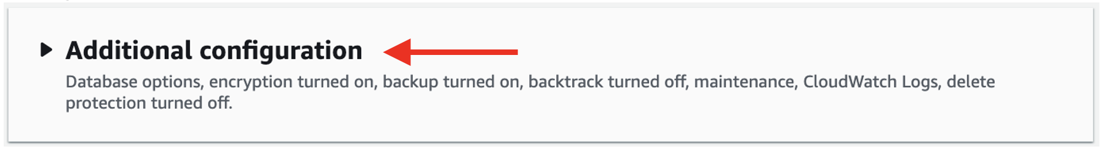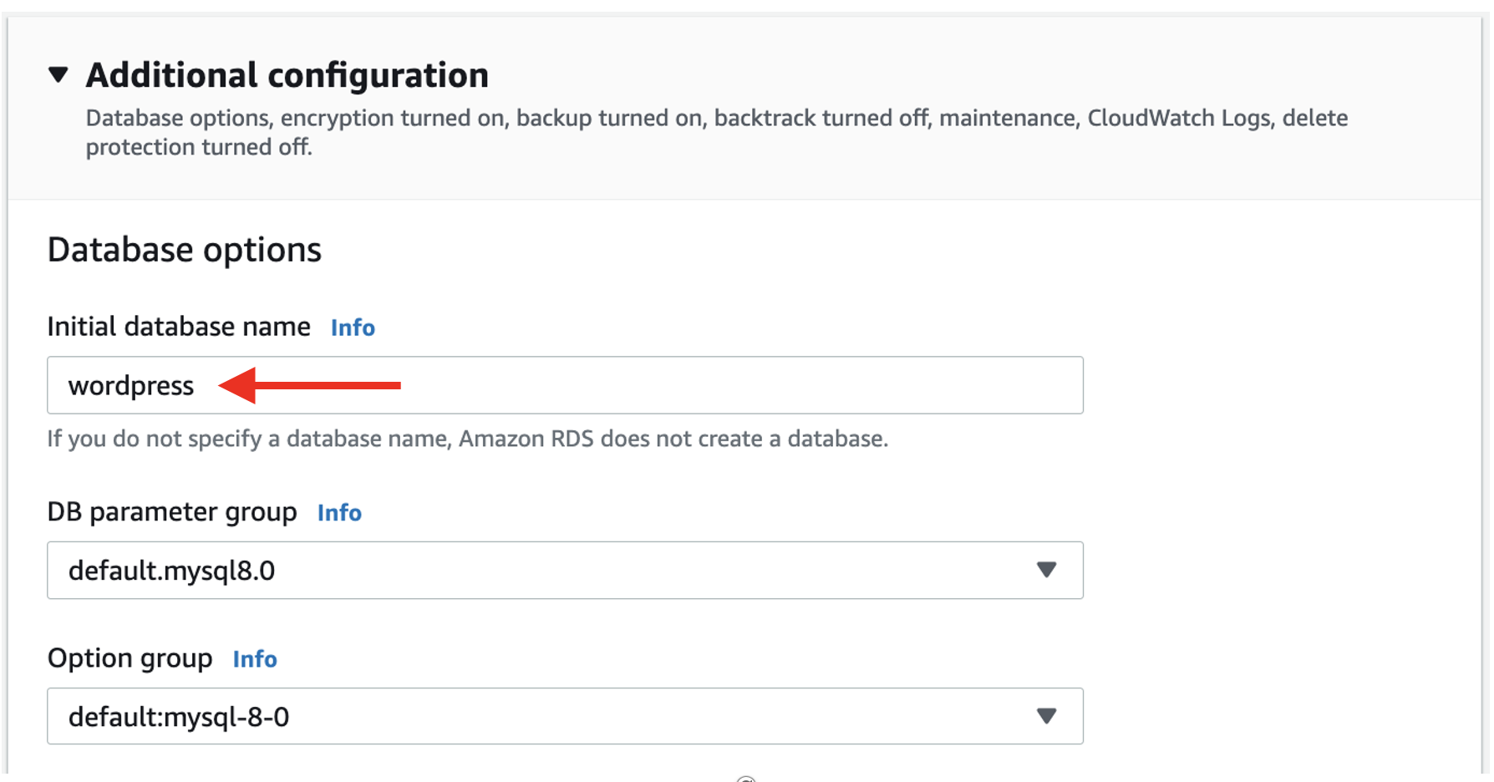

i. Retain the default settings for the remainder of options. At the bottom of the creation wizard, AWS will show you estimated monthly costs for your Amazon RDS database. If you are still eligible for the Amazon RDS Free Tier, you will see a note that the database will be free to you for up to 12 months.

Choose the Create database button to create your database.

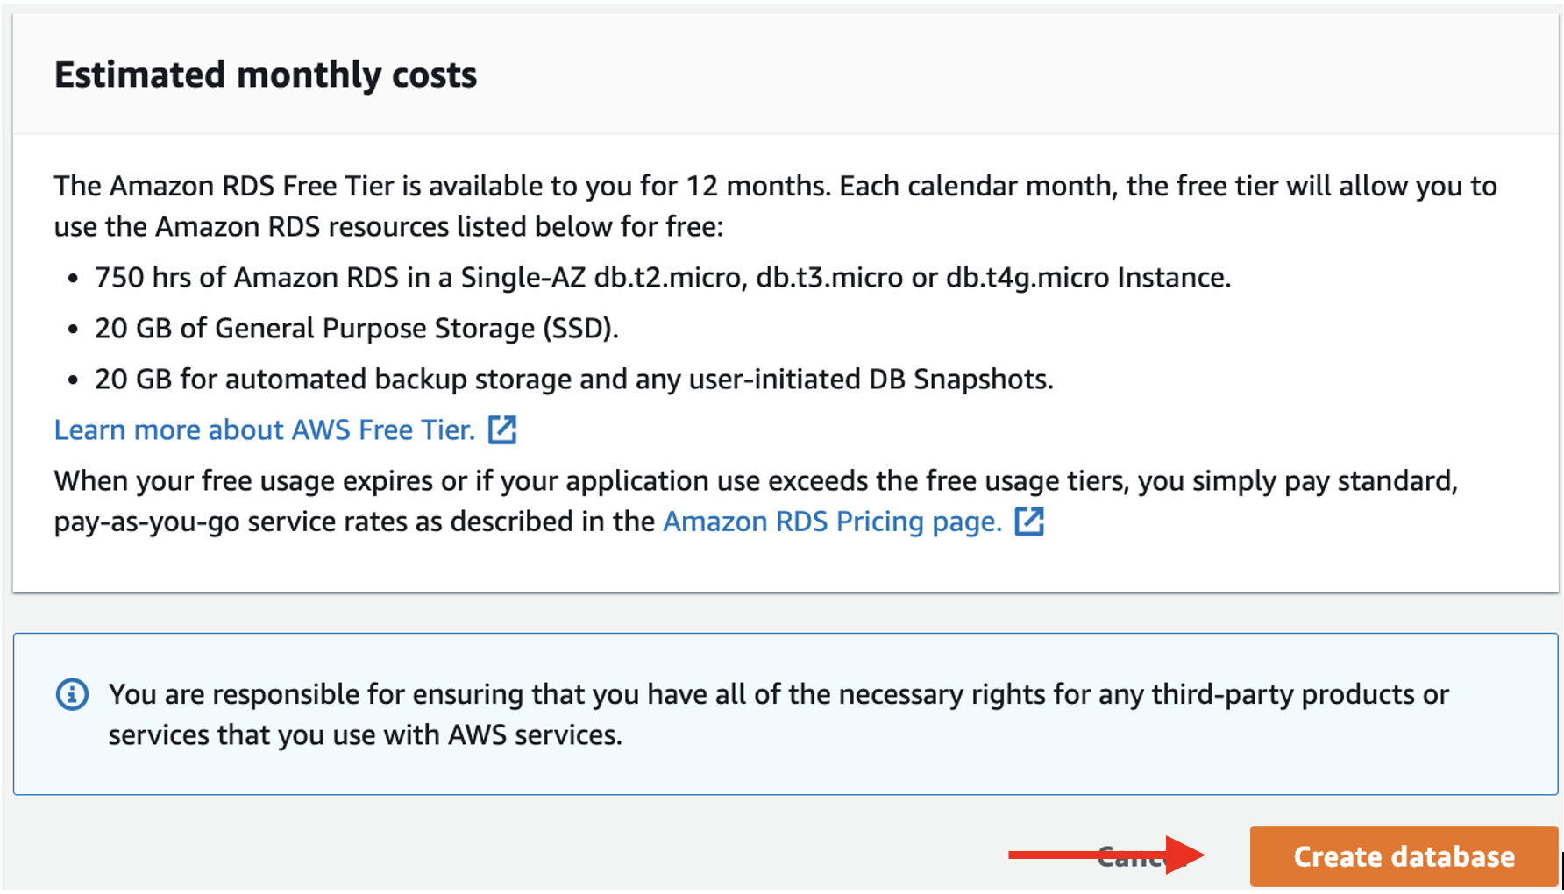

j. You should see a success notice indicating that your database is being created.

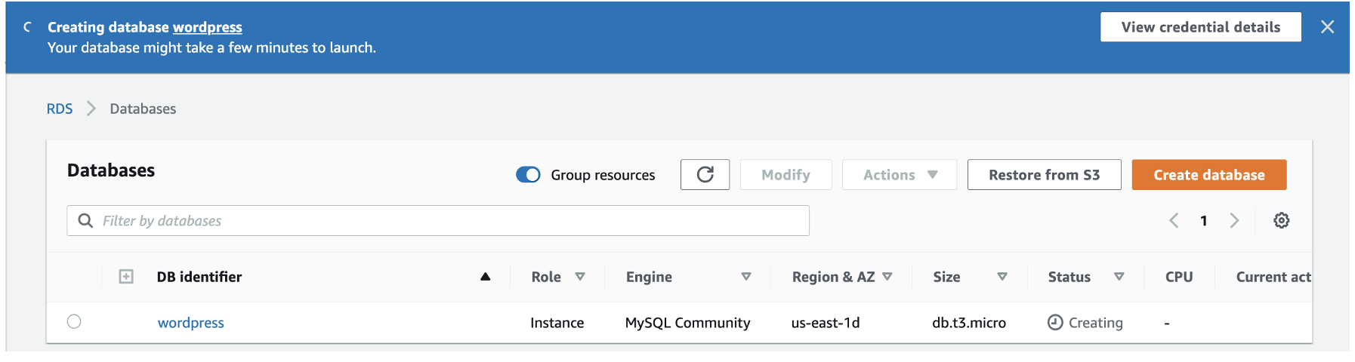

## Tạo máy ảo EC2

### Chọn AMI

a. To create your EC2 instance, go to [Amazon EC2 in the AWS Management Console](https://console.aws.amazon.com/ec2/v2/home). Choose the Launch instance button to open the instance creation wizard.

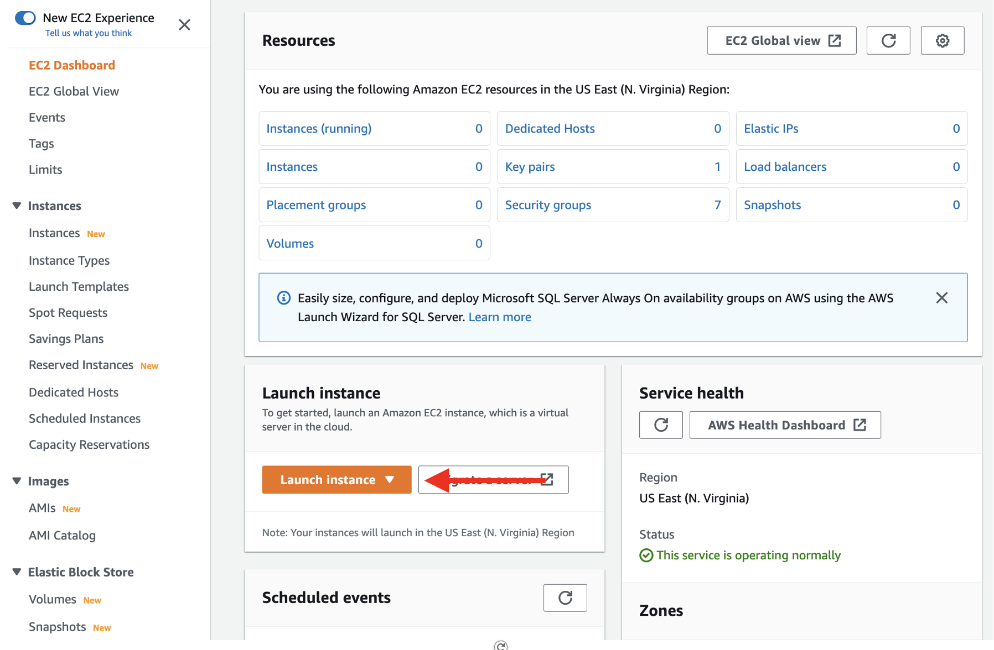

b. On the first page, enter *wordpress app* as your instance name.

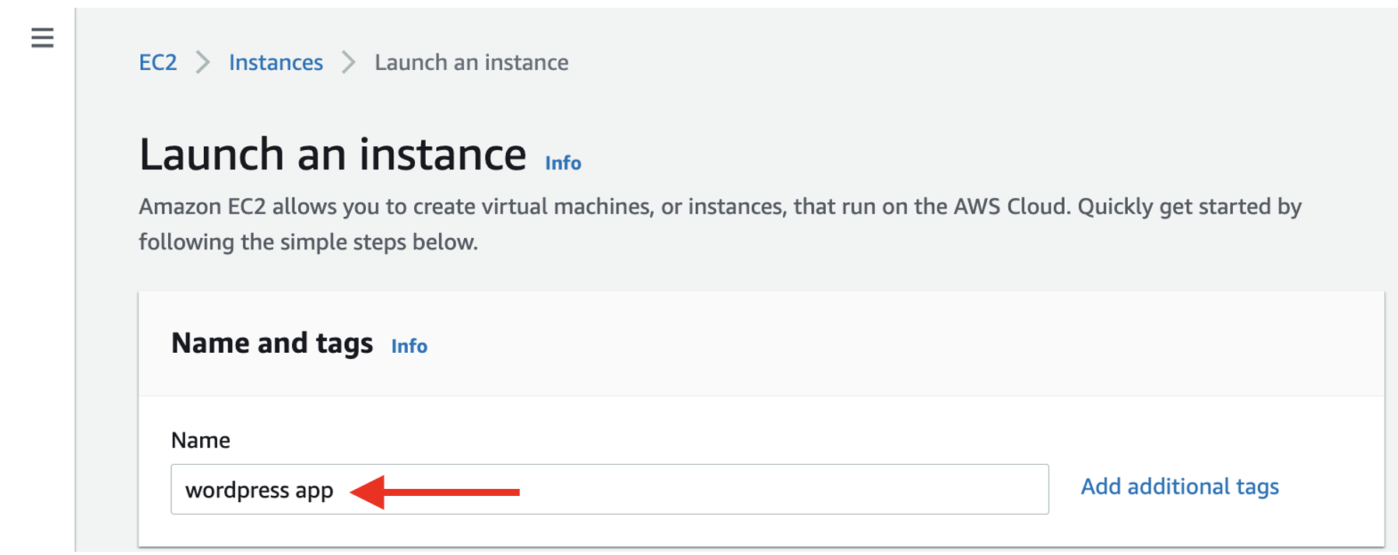

c. Next, choose an Amazon Machine Image (AMI). The AMI you choose will determine the base software that is installed on your new EC2 instance. This includes the operating system (Amazon Linux, Red Hat Enterprise Linux, Ubuntu, Microsoft Server, etc.), and the applications that are installed on the machine.  
  
Many AMIs are general-purpose AMIs for running many different applications, but some are purpose-built for specific use cases, such as the Deep Learning AMI or various AWS Marketplace AMIs.  
  
For this tutorial, choose the Amazon Linux 2 AMI (HVM) in the AMI selection view.

NOTE: Some commands in this tutorial will not work if Amazon Linux 2023 is selected.

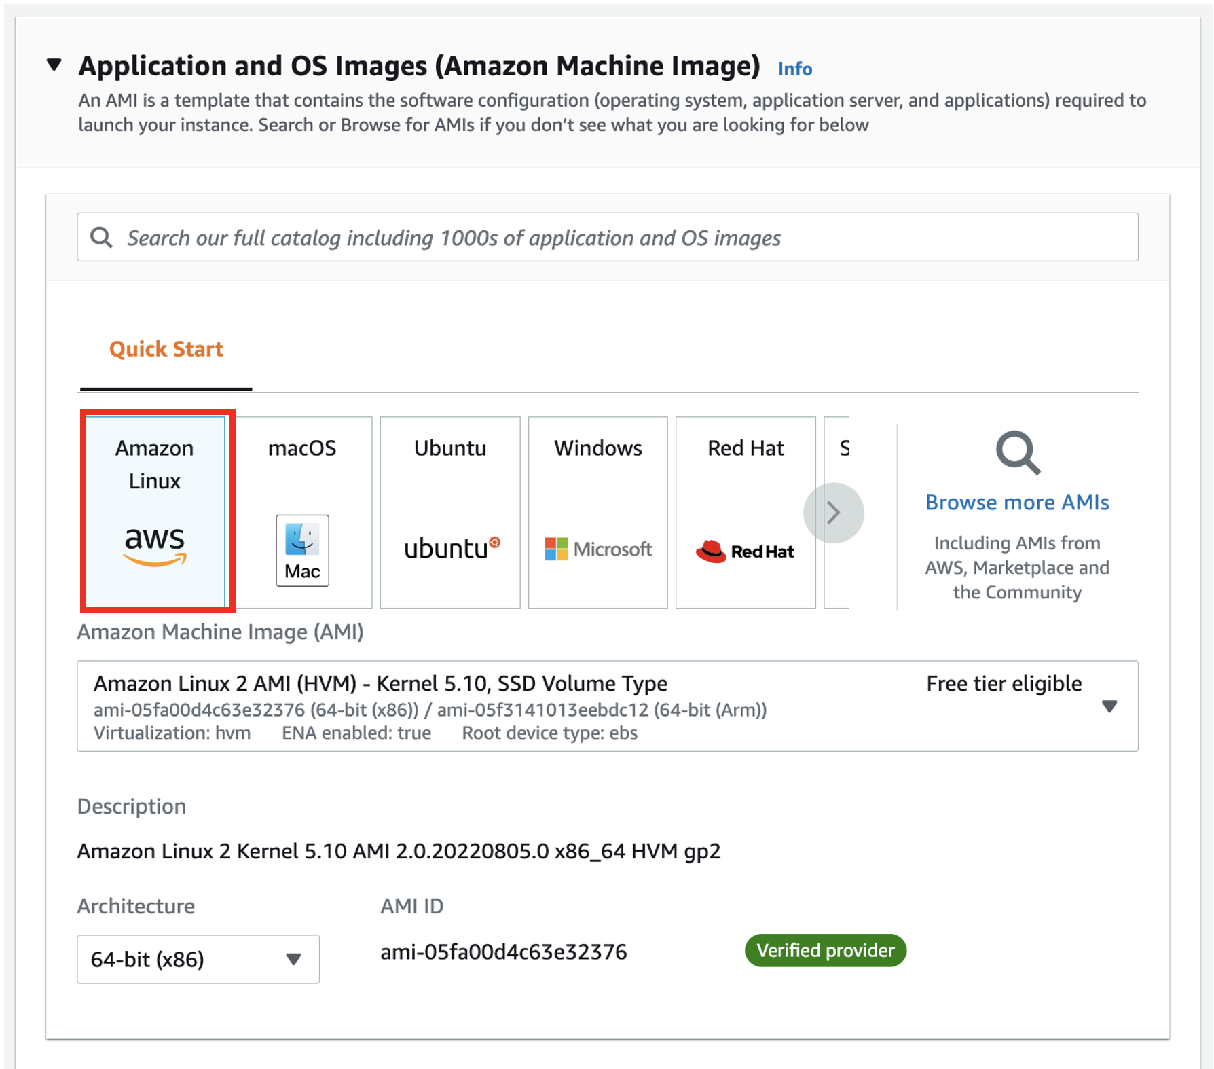

### Choosing an instance type

Scroll down to select an EC2 instance type. An instance type is a particular configuration of CPU, memory (RAM), storage, and network capacity.  
  
AWS has a huge selection of [instance types](https://aws.amazon.com/ec2/instance-types/) that cover many different workloads. Some are geared toward memory-intensive workloads, such as databases and caches, while others are aimed at compute-heavy workloads, such as image processing or video encoding.  
  
Amazon EC2 allows you to run 750 hours per month of a t2.micro instance under the [AWS Free Tier](https://aws.amazon.com/free/?all-free-tier.sort-by=item.additionalFields.SortRank&all-free-tier.sort-order=asc&awsf.Free%20Tier%20Types=*all&awsf.Free%20Tier%20Categories=*all). Select this option for this guide so that you won’t incur any costs on your bill.

a. Select the t2.micro instance.

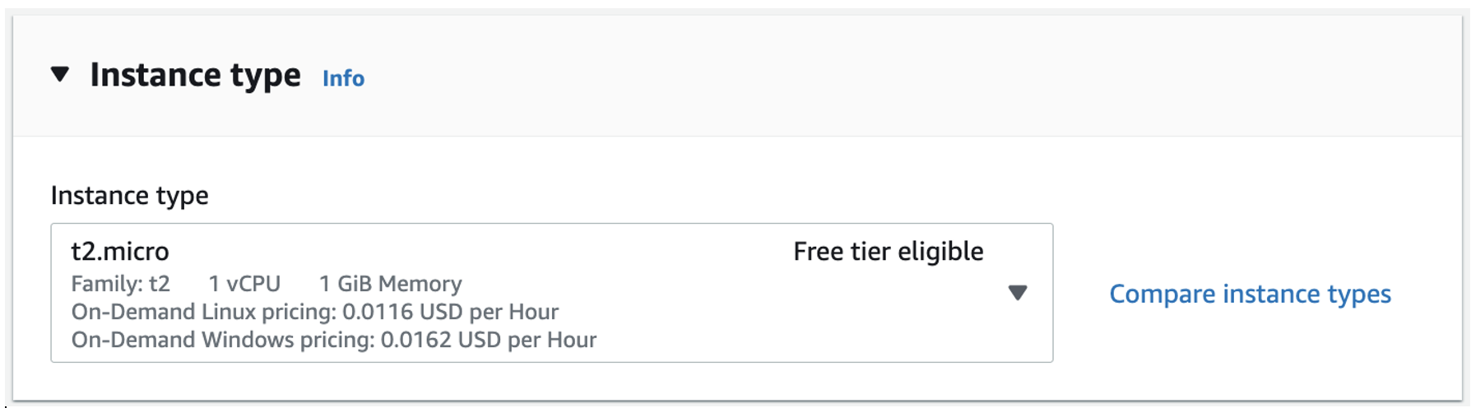

### Configuring an SSH key

You will see a details page on how to configure a key pair for your instance. You will use the key pair to [SSH](https://en.wikipedia.org/wiki/Secure_Shell) into your instance, which will give you the ability to run commands on your server.

a. Open the key pair (login) section and choose Create new key pair for your instance.

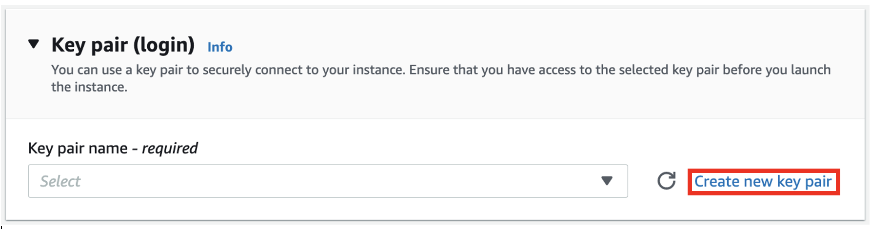

b. Give your key pair a name. Then choose the Create key pair button, which will download the .pem file to your machine. You will use this file in the next module.

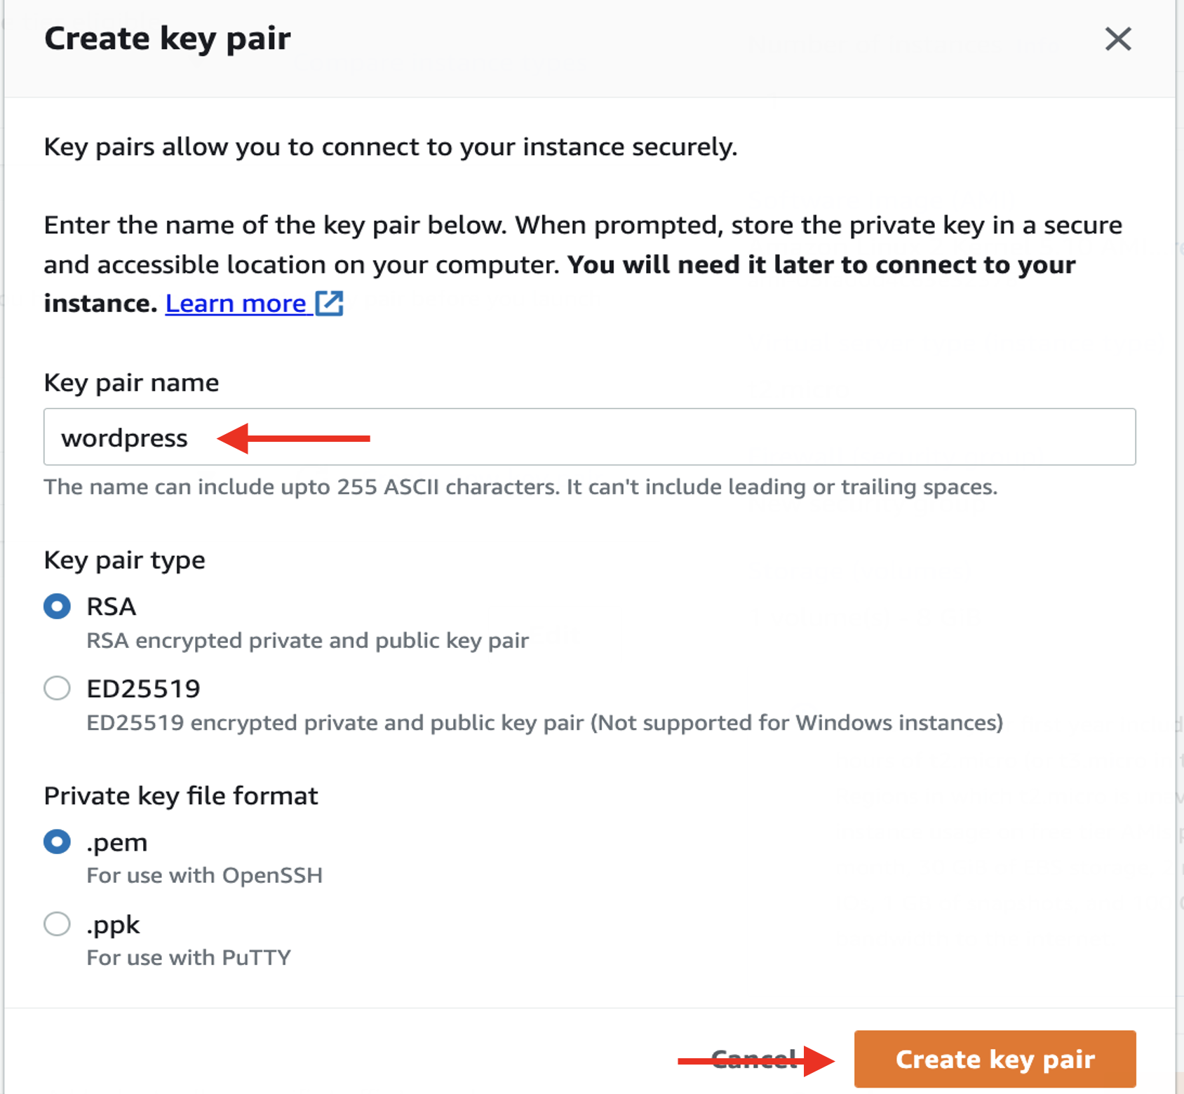

### Configuring a security group and lauching your instance

You need to configure a security group before launching your instance. Security groups are networking rules that describe the kind of network traffic that is allowed to your EC2 instance. You want to allow two kinds of traffic to your instance:

* SSH traffic from your current IP address so you can use the SSH protocol to log in to your EC2 instance and configure WordPress
* HTTP traffic from all IP addresses so that users can view your WordPress site.

a. To configure this, select Allow SSH traffic from My IP and select Allow HTTP traffic from the internet.

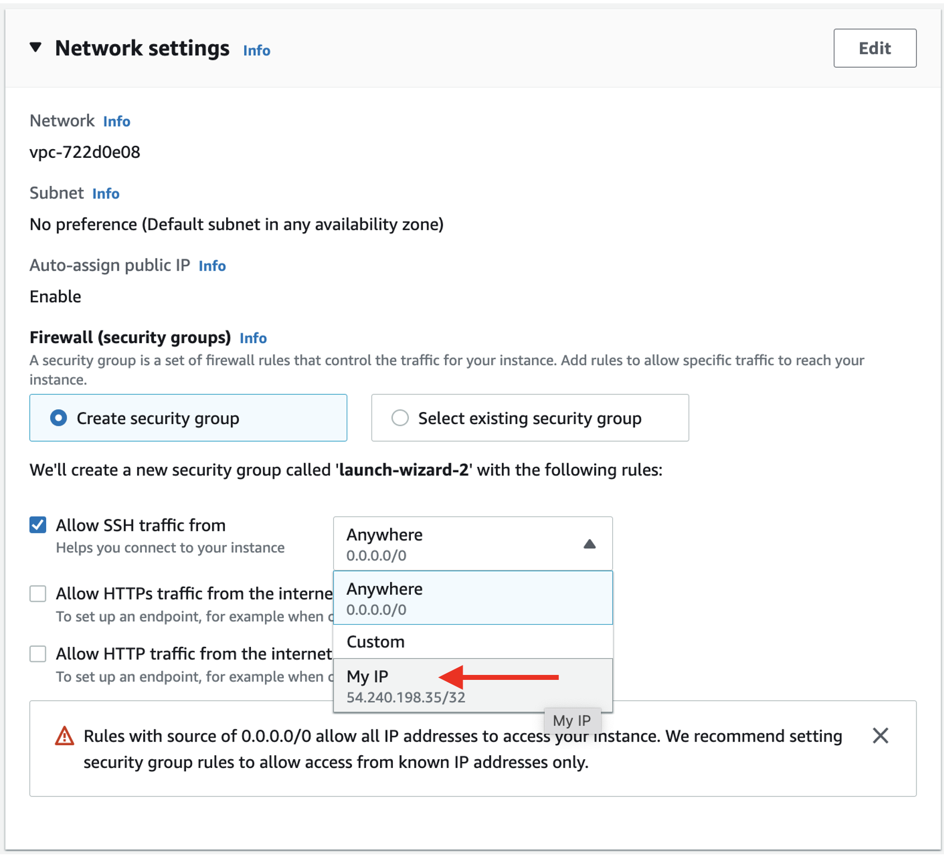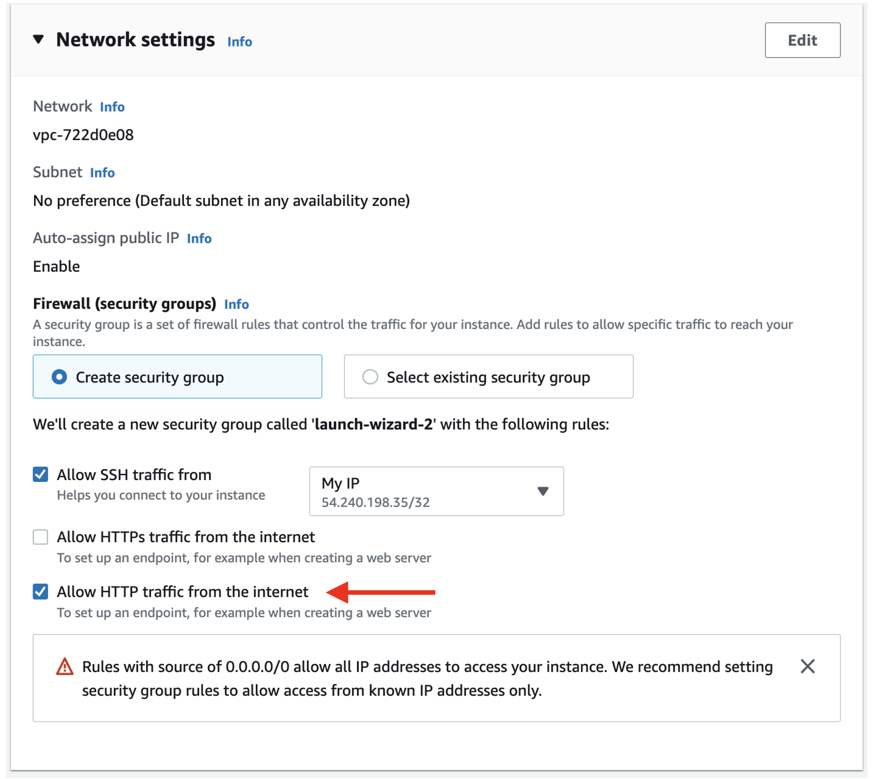

b. In the Network settings section, choose the Edit button. Scroll down to Firewall (security groups) and enter *wordpress* for the Security group name.

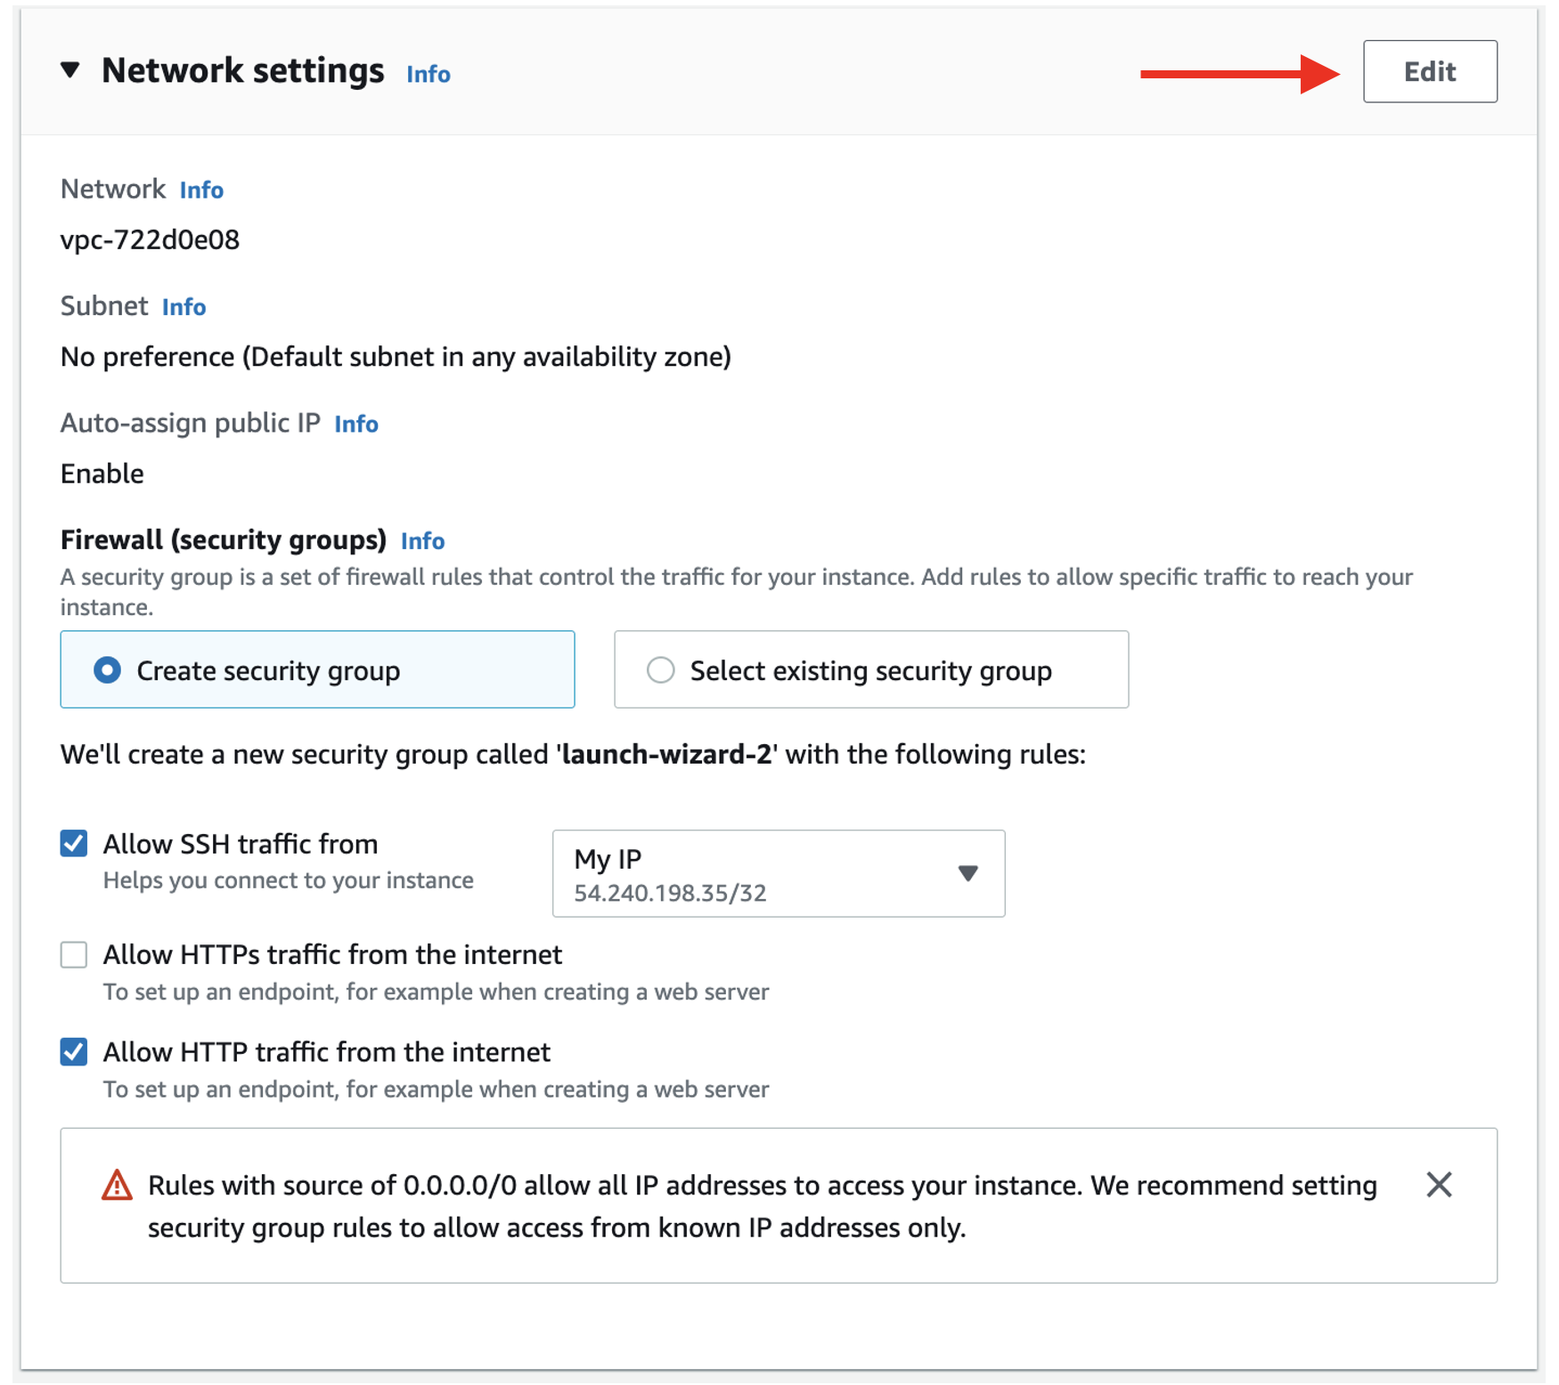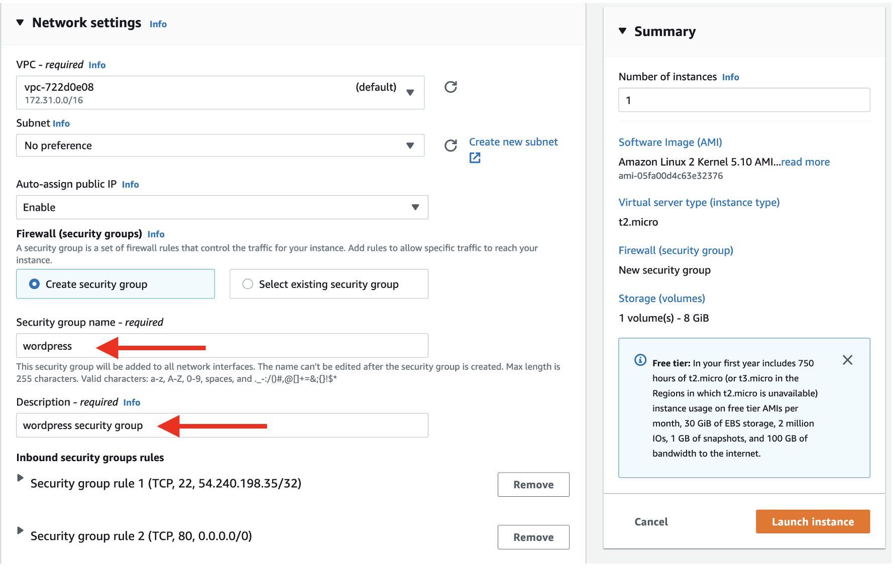

### Launch

It is now time to launch your EC2 instance.

a. Choose the Launch instance button to create your EC2 instance.

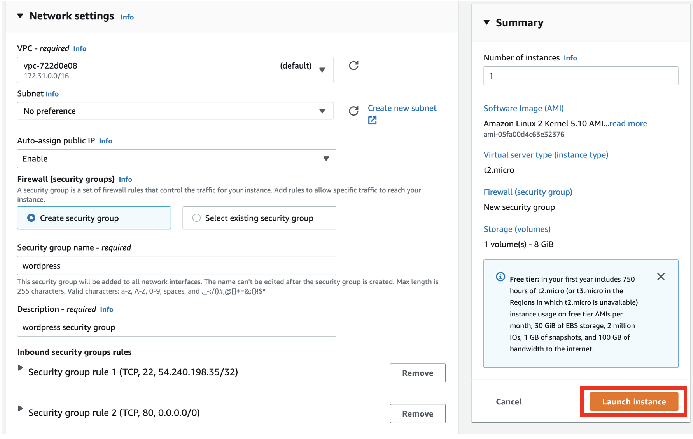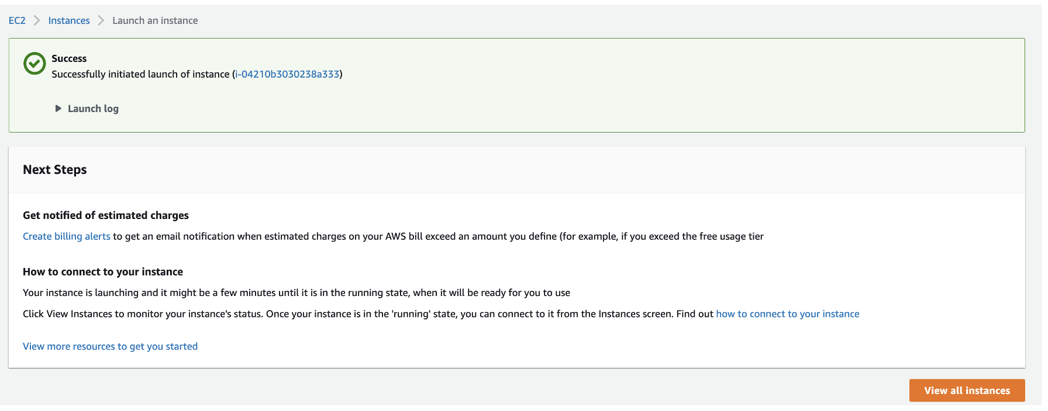

### Thông Kết nối Network EC2 với RDS

First, you will modify your Amazon RDS database to allow network access from your EC2 instance.

In the previous module, you created security group rules to allow SSH and HTTP traffic to your WordPress EC2 instance. The same principle applies here. This time, you want to allow certain traffic from your EC2 instance into your Amazon RDS database.

a. To configure this, go to the Amazon RDS databases page in the AWS console. Choose the MySQL database you created in the earlier module in this guide.

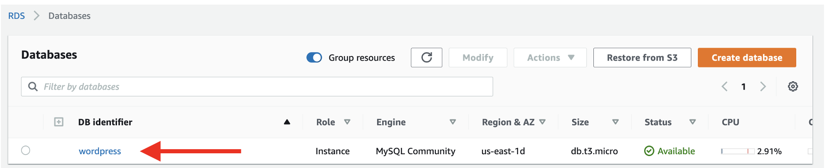

b. Scroll to the Connectivity & security tab in the display and choose the security group listed in VPC security groups. The console will take you to the security group configured for your database.

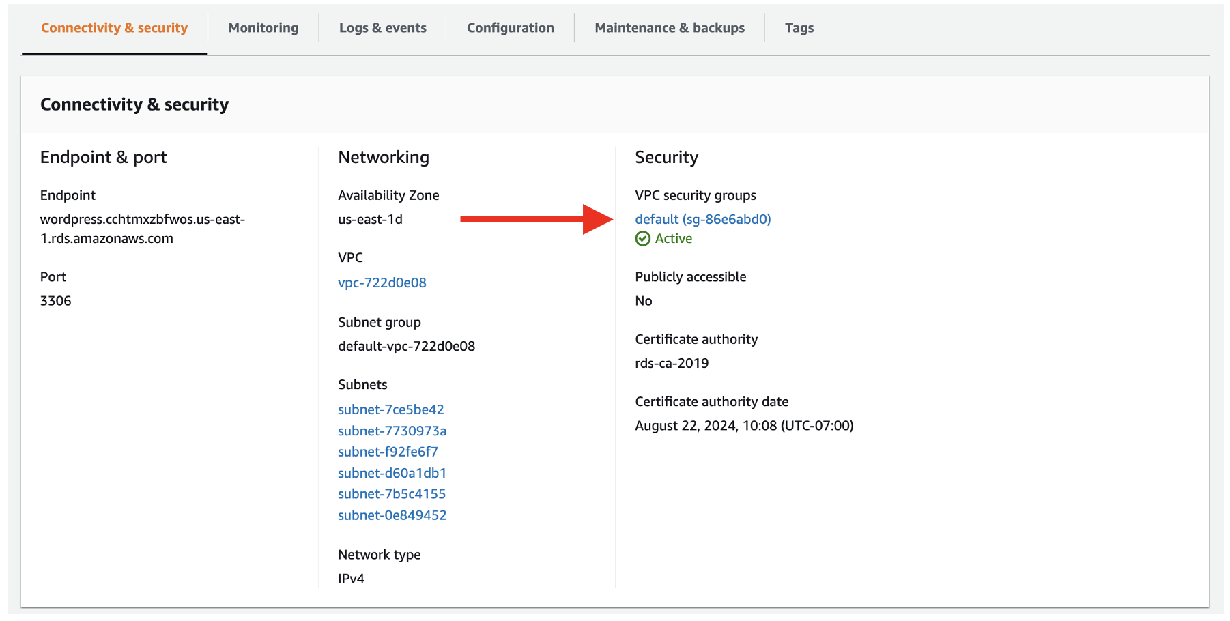

c. Select the Inbound rules tab, then choose the Edit inbound rules button to change the rules for your security group.

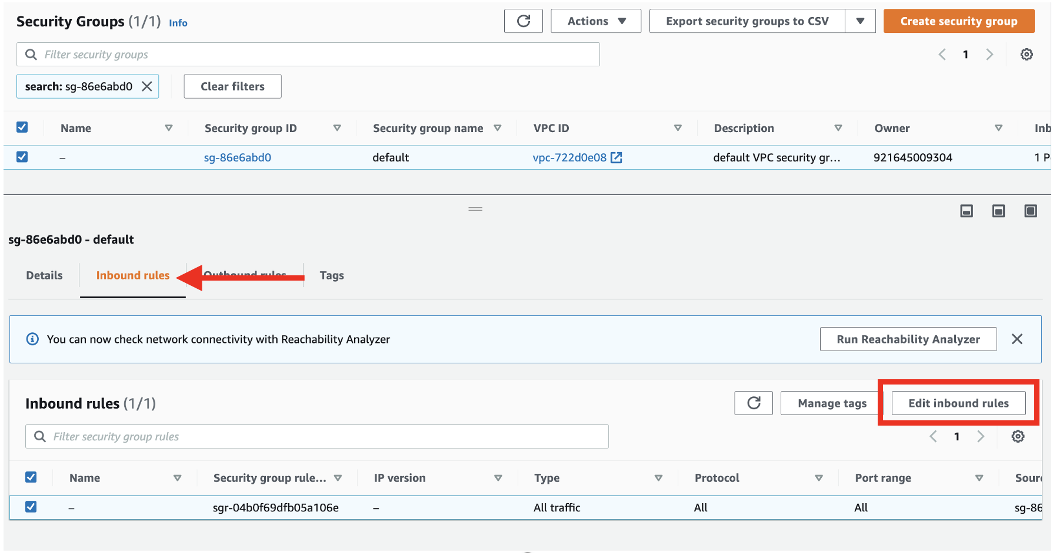

d. The default security group has a rule that allows all inbound traffic from other instances in the default security group. However, since your WordPress EC2 instance is not in that security group, it will not have access to the Amazon RDS database.

Change the Type property to MYSQL/Aurora, which will update the Protocol and Port range to the proper values. Then, remove the current security group value configured for the Source.

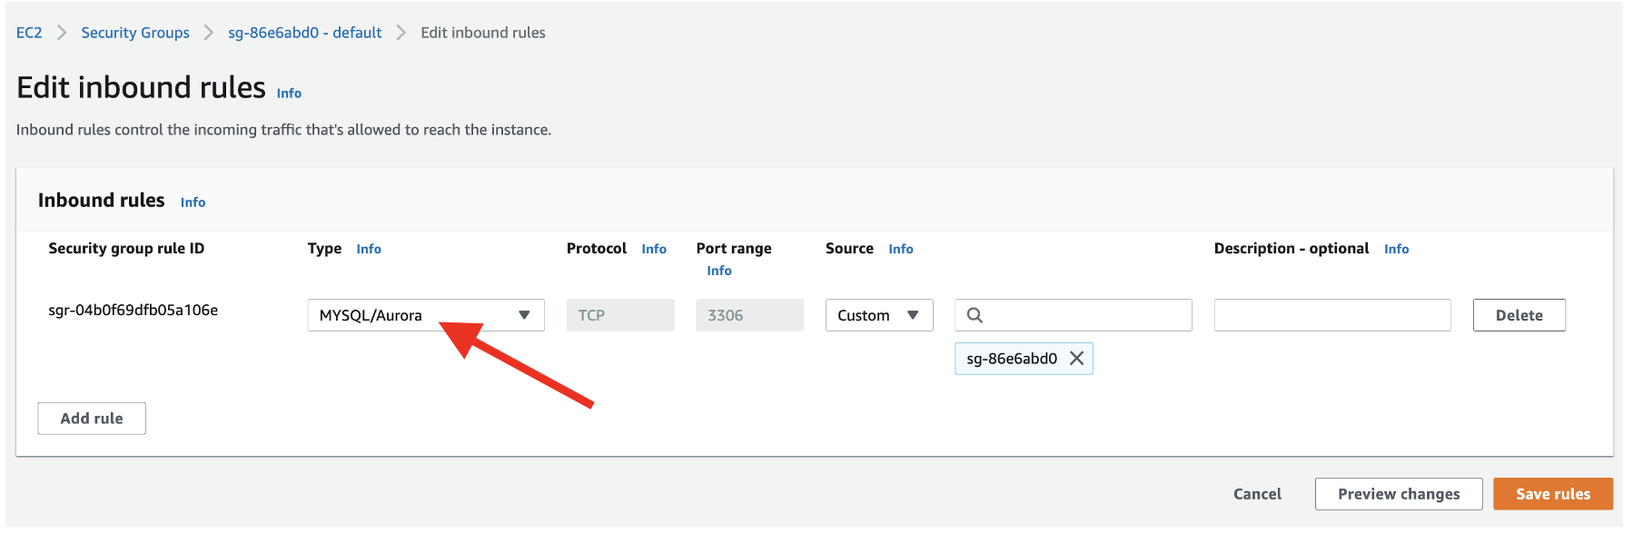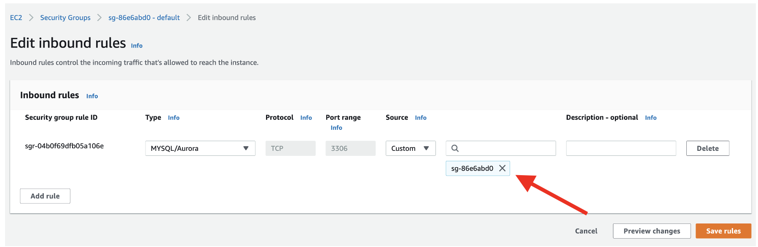

e. For Source, enter *wordpress.* The console will show the available security groups that are configured. Choose the wordpress security group that you used for your EC2 instance.

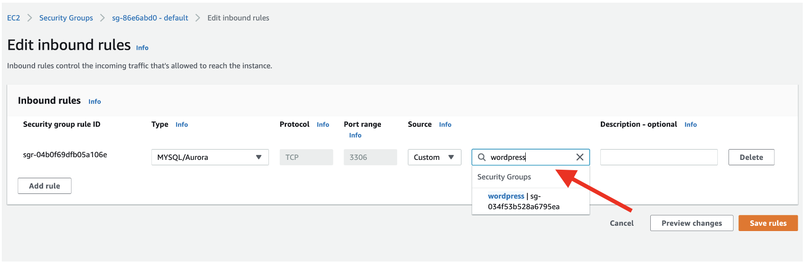

f. After you choose the wordpress security group, the security group ID will be filled in. This rule will allow MySQL access to any EC2 instance with that security group configured.

When you’re finished, choose the Save rules button to save your changes.

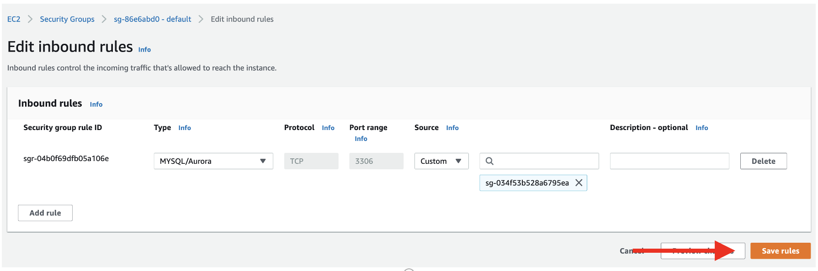

### SSH into your EC2 instance

Now that your EC2 instance has access to your Amazon RDS database, you will use SSH to connect to your EC2 instance and run some configuration commands.

a. Go to the [EC2 instances page](https://console.aws.amazon.com/ec2/v2/home#Instances) in the console. You should see the EC2 instance you created for the WordPress installation. Select it and you will see the Public IPv4 address and the Public IPv4 DNS in the instance description.

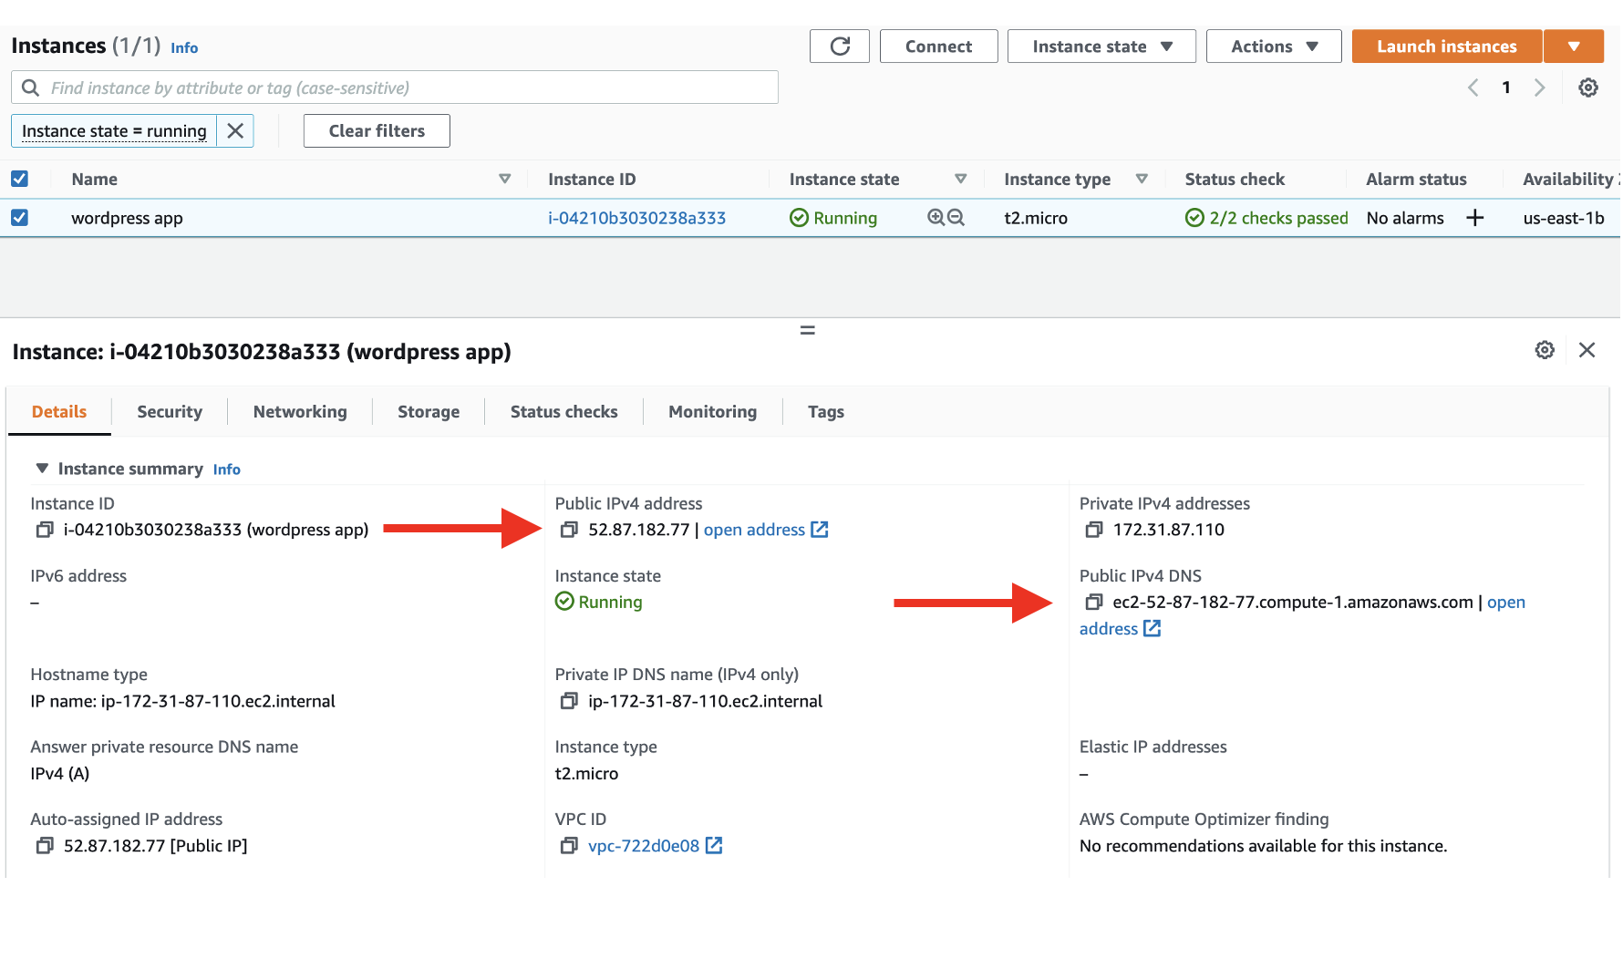

b. Previously, you downloaded the .pem file for the key pair of your instance. Locate that file now. It will likely be in a Downloads folder on your desktop.

*For Mac or Linux users:*

Open a terminal window. If you are on a Mac, you can use the default Terminal program that is installed, or you can use your own terminal.

In your terminal, run the following commands to use SSH to connect to your instance. Replace the “<path/to/pem/file>” with the path to your file, e.g., “~/Downloads/wordpress.pem”, and the “<publicIpAddress>” with the public IP address for your EC2 instance.

chmod 400 <path/to/pem/file>   
ssh -i <path/to/pem/file> ec2-user@<public_IP_DNSAddress>

You should see the following in your terminal to indicate that you connected successfully:

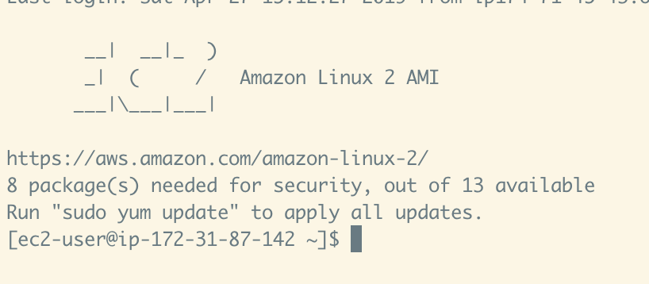

*For Windows users:*

You will need to use [PuTTY](https://www.putty.org/), an SSH client for Windows, to connect to your EC2 instance. For instructions on doing this, see this guide for [Connecting to your Linux instance from Windows using PuTTY](https://docs.aws.amazon.com/AWSEC2/latest/UserGuide/putty.html). You will need the .pem file you downloaded and the public IP address of your EC2 instance.

In this step, you connected to your EC2 instance using SSH. In the next step, you will connect to your Amazon RDS database from your EC2 instance and create a database user for the WordPress application.

### Tạo DB User cho ứng dụng và thử kết nối từ VM

You should have an active SSH session to your EC2 instance in the terminal. Now, you will connect to your MySQL database.

First, run the following command in your terminal to install a MySQL client to interact with the database.

sudo yum install -y mysql

Note: If an error occurs with this command, please verify you launched the right EC2 instance in module 2.

Next, find the hostname for your Amazon RDS database in the AWS console. In the details of your Amazon RDS database, the hostname will be shown as the Endpoint in the Connectivity & security section.

a. Go to the [Amazon RDS databases page](https://us-east-1.console.aws.amazon.com/rds/home?region=us-east-1#databases:) in the AWS console. You should see the wordpress database you created for the WordPress installation. Select it to find the hostname for your Amazon RDS database.

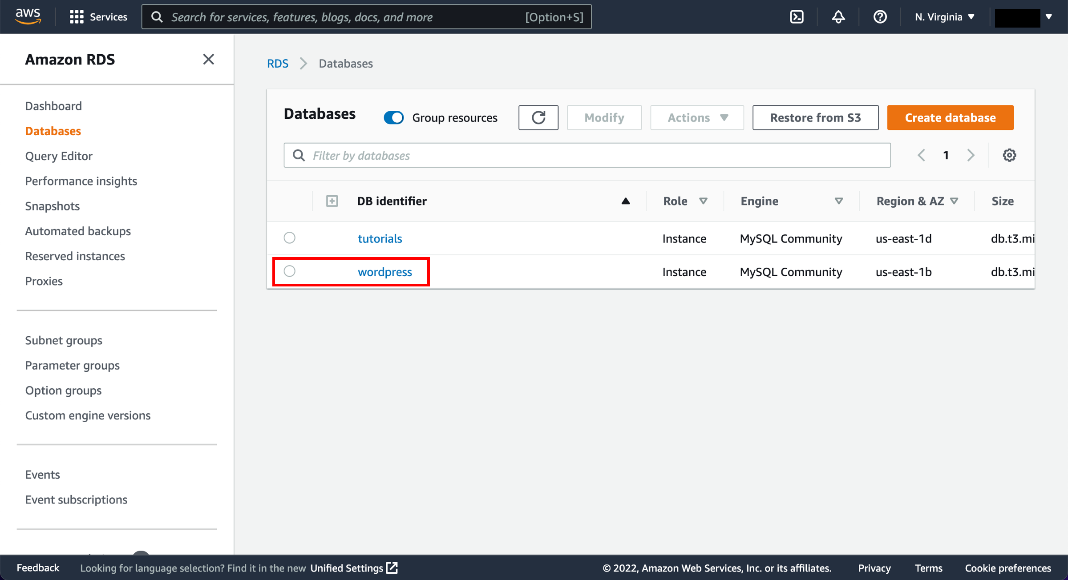

b. In the details of your Amazon RDS database, the hostname will be shown as the Endpoint in the Connectivity & security section.

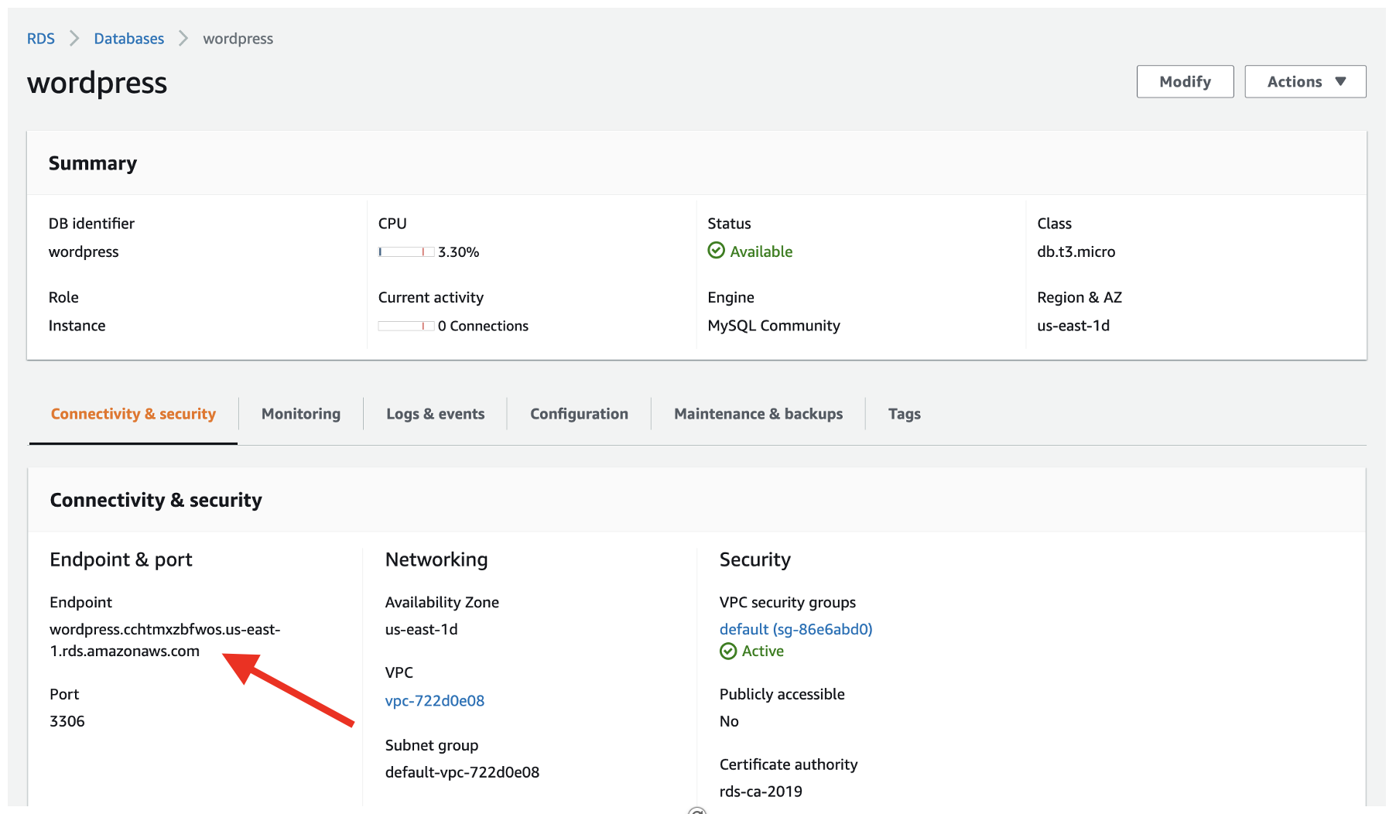

In your terminal, enter the following command to set an environment variable for your MySQL host. Be sure to replace “<your-endpoint>” with the hostname of your RDS instance.

export MYSQL_HOST=<your-endpoint>

Copy

Next, run the following command in your terminal to connect to your MySQL database. Replace “<user>” and “<password>” with the master username and password you configured when creating your Amazon RDS database.

mysql --user=<user> --password=<password> wordpress

Copy

Finally, create a database user for your WordPress application and give the user permission to access the wordpress database.

Run the following commands in your terminal:

CREATE USER 'wordpress' IDENTIFIED BY 'wordpress-pass';  
GRANT ALL PRIVILEGES ON wordpress.* TO wordpress;  
FLUSH PRIVILEGES;  
Exit

Copy

As a best practice, you should use a better password than *wordpress-pass* to secure your database.

Write down both the username and password that you configure, as they will be needed in the next module when setting up your WordPress installation.

In this module, you learned how to configure network and password security for your Amazon RDS database. Your EC2 instance now has network access to your Amazon RDS database. Further, you created a database user to be used by your WordPress application.

## Tạo Storage EFS ( Elastic File System)

Mục đích: Sourcecode + data của wordpress sẽ lưu tại đây. ổ cứng EFS sẽ được gắn vào các VM. và chia sẻ với tất cả các VM thông qua NFS protocol cùng 1 dữ liệu giống nhau.

### Create EFS

* Go to EFS console and click on **create file system**
* Enter the name of EFS
* Select the VPC in which you have launched RDS and EC2
* Select **Regional** in the **Availability and Durability** and click on Create

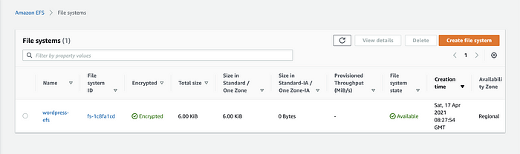

AWS EFS

* once file system is available click on it and click on Edit in General in the **Lifecycle management** select **None**, click on save changes. The reason behind doing this is by default if you don’t access the object from the file system it will move that object into the **Standard — Infrequent Access storage class**
* Change **Throughput Mode** to Provisioned and enter the desired value. This will help us in fast reading from the file system during high traffic

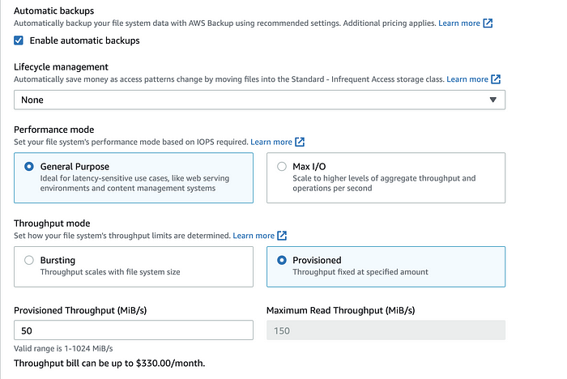

### Attach EFS to EC2

* Once you are done with the changes SSH into the EC2 Instance and we will attach this file system to EC2 Instance so that it can store the data into file system
* Create /var/www/html directory using following command. We will store all our content under this directory used by Apache Web Server

sudo mkdir -p /var/www/html/

* Mount the file system using following command

sudo mount -t nfs4 -o nfsvers=4.1,rsize=1048576,wsize=1048576,hard,timeo=600,retrans=2,noresvport <file_system_id>.efs.<region>.amazonaws.com:/ /var/www/html/

you can get this command from file system console as well. You just need to click on file system and you will see the Attach button, click on that button and you will get the command.

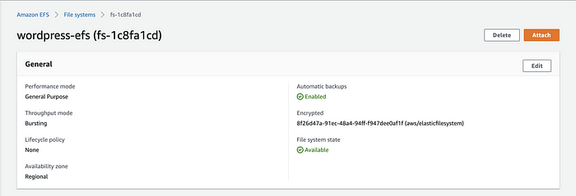

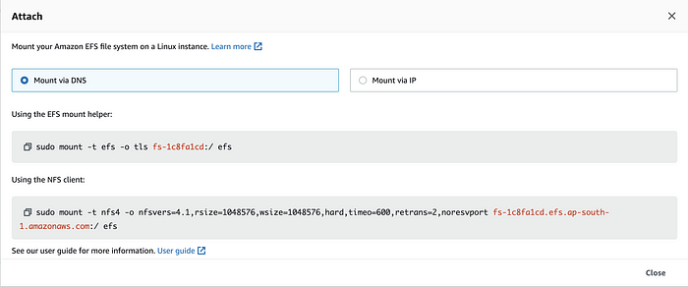

**Note:** Make sure you replace efs with /var/www/html

* Check that file system is mounted to EC2 using following command

df -T -h

Now that our file system mount is successful we are good to go ahead but before that we will configure our EC2 Instance to **Auto Mount the file system** whenever it gets rebooted due to any of the reasons

* Install the following package

sudo yum install -y amazon-efs-utils

* Open file /etc/fstab in your favourite text editor and add the following line

<file_system_id>.efs.<region>.amazonaws.com:/ /var/www/html/ efs defaults,_netdev 0 0

Now whenever your EC2 instance gets rebooted due to some reason it will mount the file system automatically.

## Cài đặt WordPress

### Cài đặt Apache webserver

To run WordPress, you need to run a web server on your EC2 instance. The open source [Apache web server](https://httpd.apache.org/) is the most popular web server used with WordPress.

To install Apache on your EC2 instance, run the following command in your terminal:

sudo yum install -y httpd

You should see some terminal output of the necessary packages being installed.

To start the Apache web server, run the following command in your terminal:

sudo service httpd start

You can see that your Apache web server is working and that your security groups are configured correctly by visiting the public DNS of your EC2 instance in your browser.

Go to the [EC2 Instances page](https://console.aws.amazon.com/ec2/v2/home#Instances) and find your instance. In the Description below, find the Public IPv4 DNS of your instance.

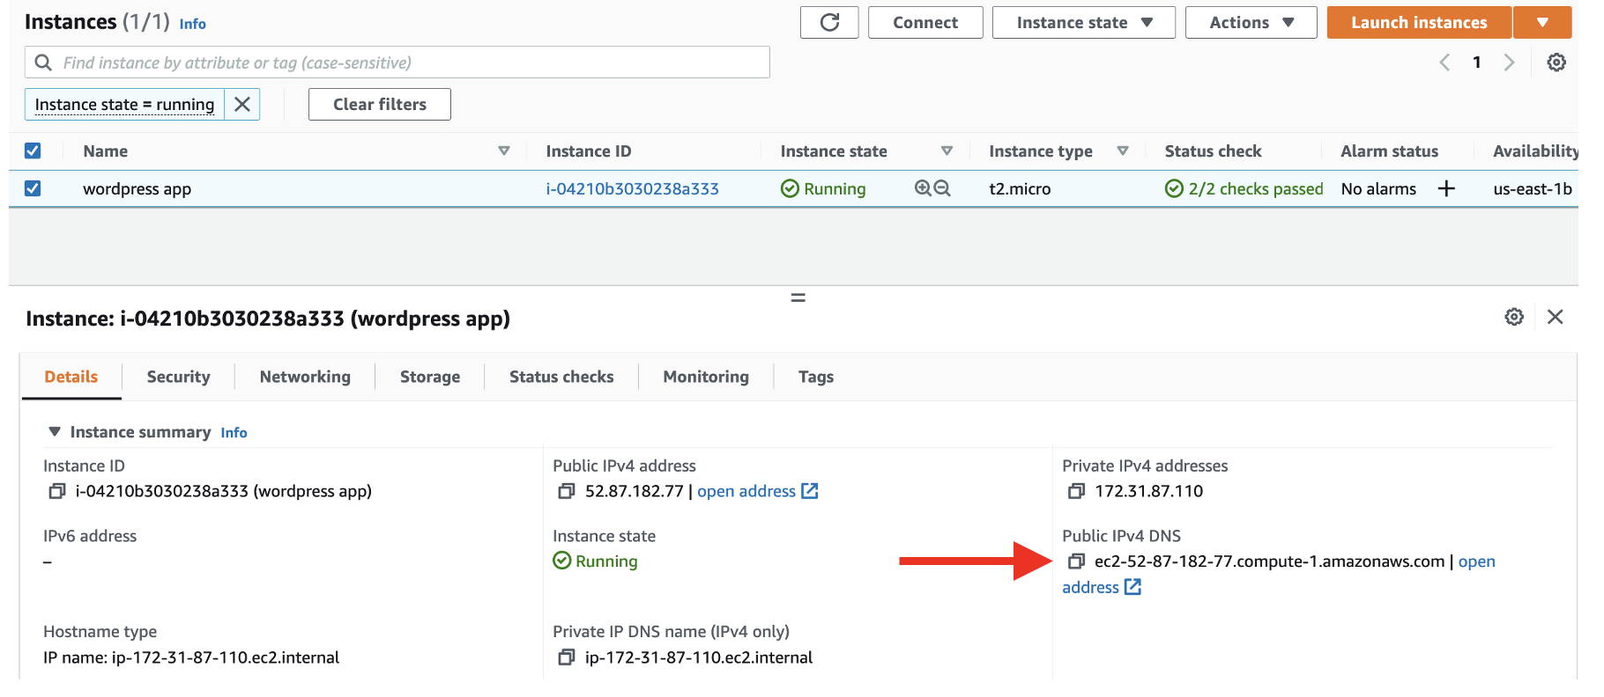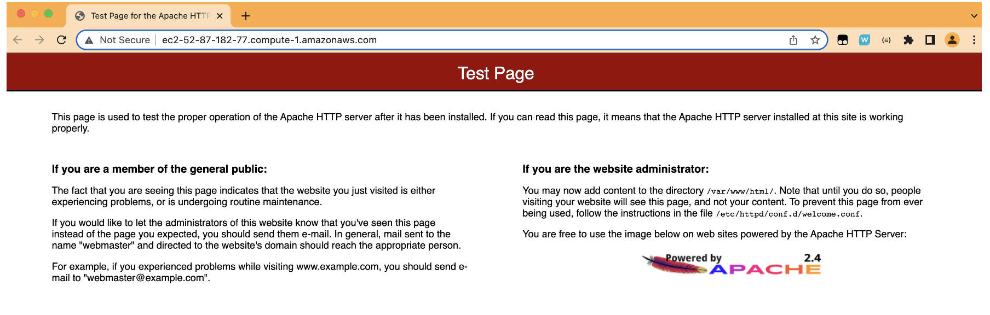

### Download and configure Wordpress

In this step, you will download the WordPress software and set up the configuration.

First, download and uncompress the software by running the following commands in your terminal:

wget <https://wordpress.org/latest.tar.gz>tar -xzf latest.tar.gz

If you run ls to view the contents of your directory, you will see a tar file and a directory called wordpress with the uncompressed contents.

$ ls

The output should look like the following:

[ec2-user@~]$ ls  
latest.tar.gz wordpress

Change the directory to the wordpress directory and create a copy of the default config file using the following commands:

cd wordpress  
cp wp-config-sample.php wp-config.php

Then, open the wp-config.php file using the [nano](https://www.nano-editor.org/) editor by running the following command.

nano wp-config.php

You need to edit two areas of configuration.

First, edit the database configuration by changing the following lines:

// ** MySQL settings - You can get this info from your web host ** //  
/** The name of the database for WordPress */  
define( 'DB_NAME', 'database_name_here' );  
  
/** MySQL database username */  
define( 'DB_USER', 'username_here' );  
  
/** MySQL database password */  
define( 'DB_PASSWORD', 'password_here' );  
  
/** MySQL hostname */  
define( 'DB_HOST', 'localhost' );

The values should be:

* DB_NAME: “wordpress”
* DB_USER: The name of the user you created in the database in the previous module
* DB_PASSWORD: The password for the user you created in the previous module
* DB_HOST: The hostname of the database that you found in the previous module

The second configuration section you need to configure is the Authentication Unique Keys and Salts. It looks as follows in the configuration file:

/**#@+  
 * Authentication Unique Keys and Salts.  
 *  
 * Change these to different unique phrases!  
 * You can generate these using the {@link <https://api.wordpress.org/secret-key/1.1/salt/> WordPress.org secret-key service}  
 * You can change these at any point in time to invalidate all existing cookies. This will force all users to have to log in again.  
 *  
 * @since 2.6.0  
 */  
define( 'AUTH_KEY', 'put your unique phrase here' );  
define( 'SECURE_AUTH_KEY', 'put your unique phrase here' );  
define( 'LOGGED_IN_KEY', 'put your unique phrase here' );  
define( 'NONCE_KEY', 'put your unique phrase here' );  
define( 'AUTH_SALT', 'put your unique phrase here' );  
define( 'SECURE_AUTH_SALT', 'put your unique phrase here' );  
define( 'LOGGED_IN_SALT', 'put your unique phrase here' );  
define( 'NONCE_SALT', 'put your unique phrase here' );

Go to [this link](https://api.wordpress.org/secret-key/1.1/salt/) to generate values for this configuration section. You can replace the entire content in that section with the content from the link.

You can save and exit from nano by entering CTRL+O [ENTER] followed by CTRL+X.

### Deploying Wordpress

In this step, you will make your Apache web server handle requests for WordPress.

First, install the application dependencies you need for WordPress. In your terminal, run the following command.

sudo amazon-linux-extras install -y mariadb10.5 php8.2

Second, change to the proper directory by running the following command:

cd /home/ec2-user

Then, copy your WordPress application files into the /var/www/html directory used by Apache.

sudo cp -r wordpress/* /var/www/html/

change user:group of **/var/www/** so that apache(httpd) can access files

sudo chown -R apache:apache /var/www/

open **/etc/httpd/conf/httpd.conf** file and make the following changes

a. Replace the following lines

<Directory />  
 AllowOverride none  
 Require all denied  
</Directory>

with the

<Directory />  
 Options FollowSymLinks  
 AllowOverride All  
</Directory>

b. scroll down to **line no 129** and change AllowOverride None to AllowOverride All

c. scroll down to **line no 155** and change AllowOverride None to AllowOverride All

Finally, restart the Apache web server to pick up the changes.

sudo service httpd restart

You should see the WordPress welcome page and the five-minute installation process.

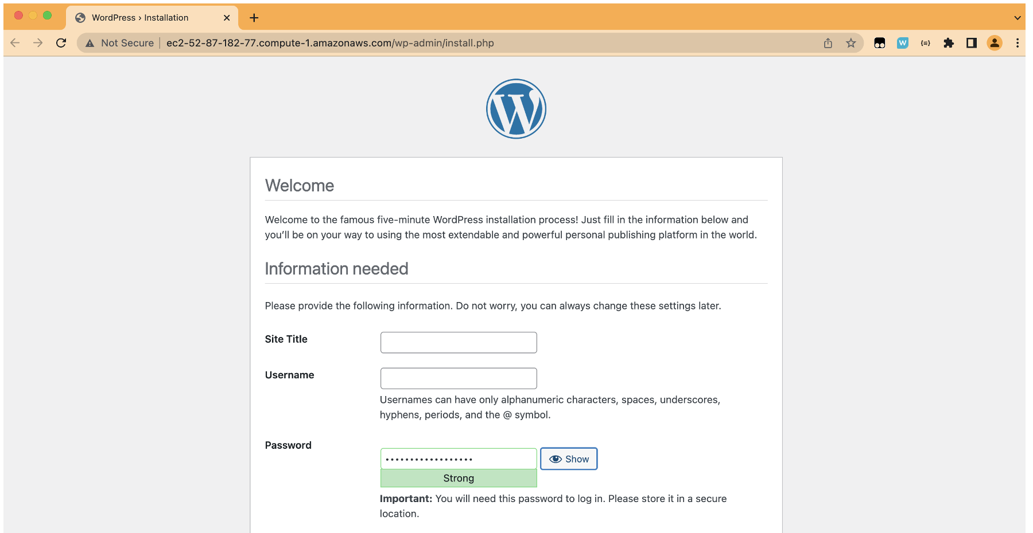

That’s it. You have a live, publicly accessible WordPress installation using a fully managed MySQL database on Amazon RDS.

## Tạo Application Loadbalance ( ALB)

* Go to EC2 Console and click on **Load Balancers** from the left navigation panel
* Click on **Create Load Balancer** button
* Select **Application Load Balancer**
* Enter the name of the Load Balancer
* Scroll down and select the VPC in which you have launched RDS and EC2 and select Availability Zones (I would recommend to select 2 or more AZs for High Availability) and select proper subnets
* Click on Next and Select the Security Group for ALB (Make sure your SG has Port 80 opened)
* In the configure routing

a. Select Create New Target Group

b. Enter the name of TG

c. Select **Target Type** -> **Instance**

d. Select **HTTP** Protocol

e. Write **80** in Port

f. Scroll down to **Advanced health check settings**

g. In the **success codes** enter **200, 301** (After Installing WordPress when we will hit the request to ALB endpoint Internally Apache Web Server will Redirect our traffic to WordPress and it will give 301 status code. Flow of the request will be — Request on ALB Endpoint -> Apache WebServer -> WordPress. So basically our Apache WebServer is redirecting the traffic so success code for TG will be 301). If you don’t add 301 in **Success Codes** while Creating TG your Target Health Check might fail with error **Getting 301 status Code**

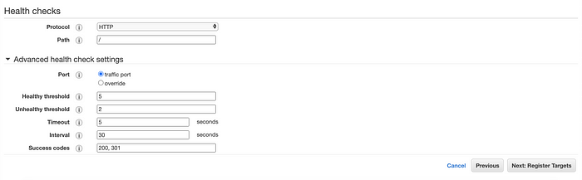

**Note:** Add 200 and 301 both the status code because till now when we hit the request the success code will be 200 but after installing and configuring WordPress the success code will be 301. Don’t forget to Add the ID of ALB Sg into the inbound rule of EC2 SG.

**Make it Highly Available**

### Tạo AMI từ EC2

* Now as I have told you that we will make this set up as Highly Available, so that because of any reason if our EC2 Instance is down then another Instance should be available to serve the requests
* We have already created AWS Elastic File System so that we can mount that to Multiple EC2 Instances and we have already moved all our code to EFS which is mounted under /var/www/html directory
* Go to AWS Console and Select your EC2 on which you have done the above configurations
* Click on Actions, Click on Image and Templates and click on Create Image button
* Enter the name and description of Image **most importantly** you must select No Reboot **Enable** CheckBox.

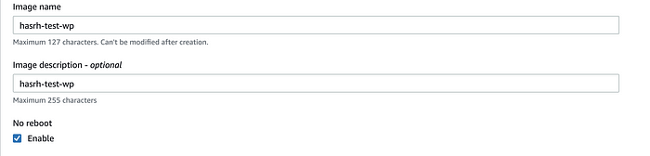

* Scroll down and click on Create Image
* You will get the image id and wait for it to become available
* Once that image is available **launch New EC2 Instance** from the Image which you have created
* You can launch as many instances you want from that image. It will have all our configurations which we have done so far.
* Once you launch the new instance verify that everything is in place

a. Check that EFS is mounted by running df -T -h command

b. Check that you have httpd service running

c. Run ls /var/www/html command and you will see all the files are present under that directory because we have mounted file system.

* Once the above things are verified go to the Target Group which you have created while creating ALB and register you new EC2 Instances in that Target Group

### Tạo ASG lauching từ AMI vừa tạo

Tạo nhóm ASG (auto scale group) và chọn khởi động máy ảo mới EC2 từ AMI vừa tạo. Máy ảo này sẽ bao gồm đầy dủ các gói cài đặt và các kết nối đế RDS và EFS.

Từ ALB chỉnh lại target group về ASG vừa tạo

## Clean up

### Remove EC2

First, you can remove your EC2 instance that is hosting your WordPress site.

Navigate to the [EC2 Instances page](https://console.aws.amazon.com/ec2/v2/home#Instances) and find your EC2 instance. Select it, and choose the Actions button. Select Instance state > Terminate instance.

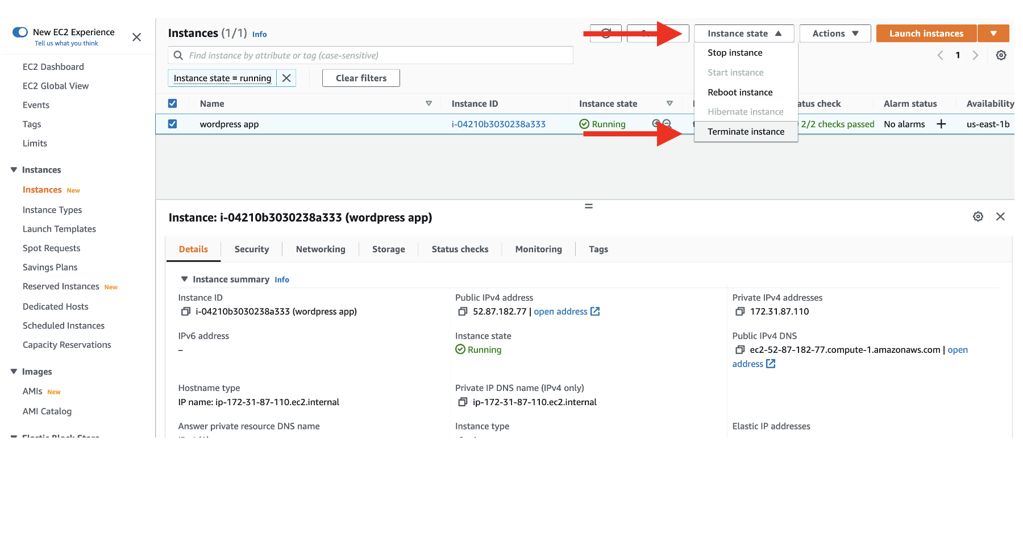

Choose the Terminate button to terminate your instance.

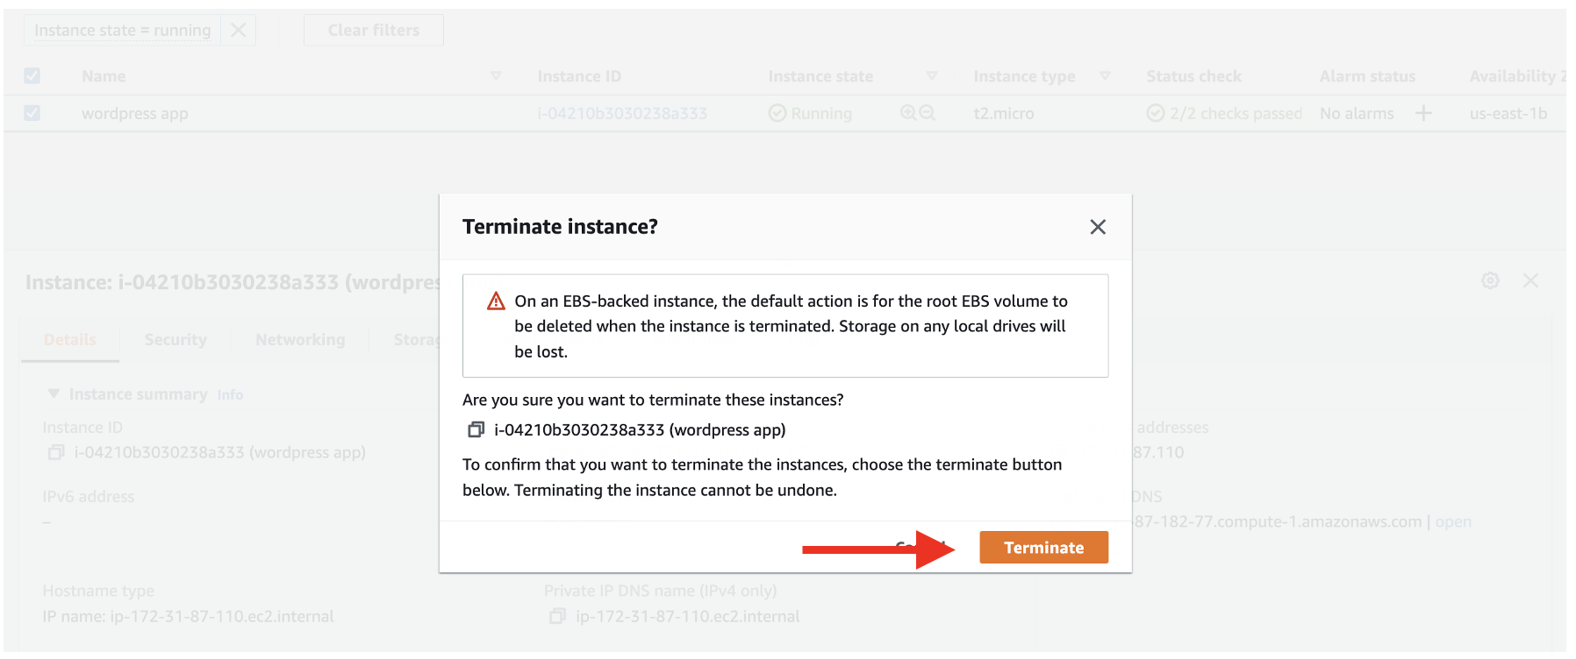

### Delete Database RDS

To delete your Amazon RDS instance, navigate to the [RDS Databases page](https://console.aws.amazon.com/rds/home#databases:) in the AWS console. Find your WordPress Amazon RDS instance and select it. Then, select Actions and Delete.

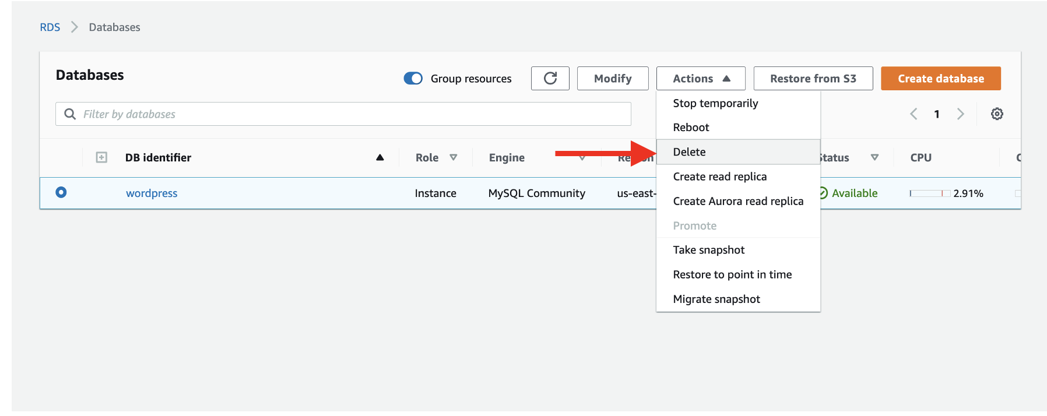

Enter *delete me* into the confirmation box and choose the Delete button to finalize the process.

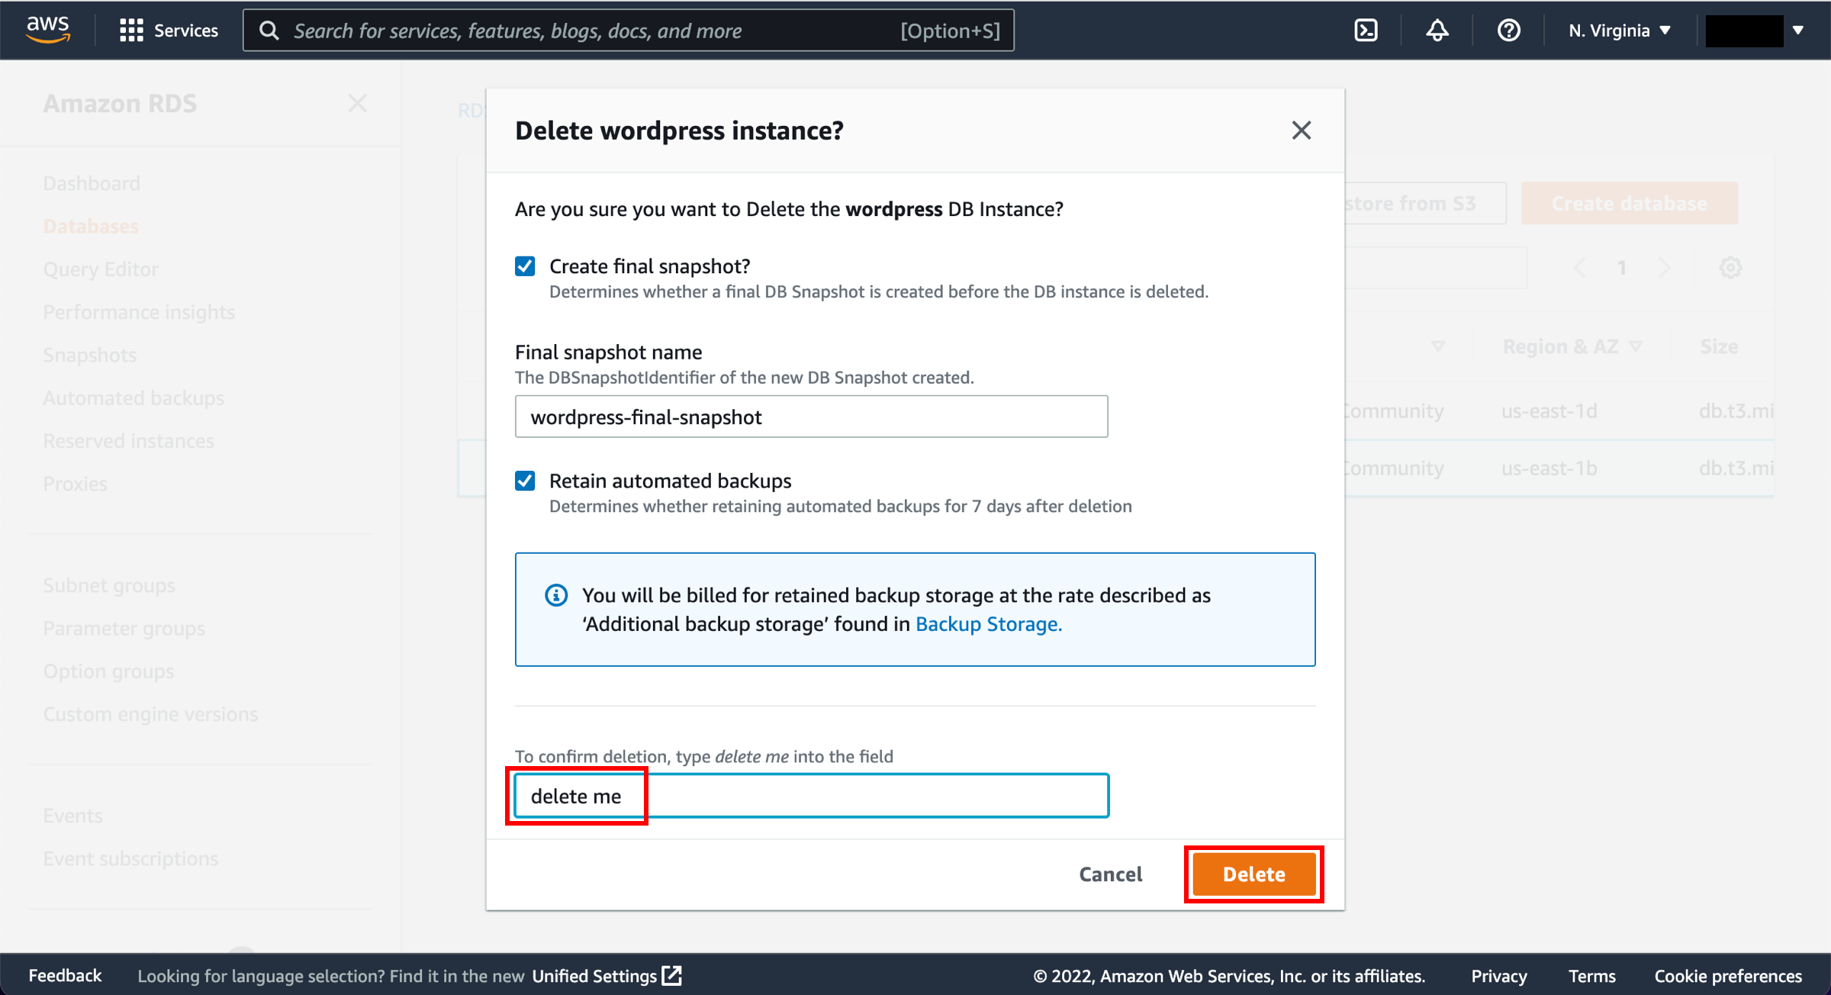

### Remove EFS

Remove EFS